

**Capstone Project Final Report**

**Project title: Social Fashion Network (SOFA)**

**Hanoi, May 6th, 2021**

**Table of Contents**

Contents

Chapter 1: Introduction 7

1. Purpose 7

2. Project Information 7

3. Project Team 7

4. Background 7

5. Literature review of the existing system 8

6. Business Opportunity 13

7. Software Product Vision 13

8. System Functions 13

9. System Overview 14

10. Out-of-scope functions 15

11. Tool and technique 15

Chapter 2: Project Plan 16

1. Purpose 16

2. Project Overview 16

3. Project management Plan 19

4. Meeting minutes 21

5. Risk management Plan 21

6. Document management Plan 22

7. Source code management Plan 22

Chapter 3: Software Requirement Specification 22

1. Purpose 22

2. User requirements 23

3. Functional Requirements 75

4. Non-Functional Requirements 23

5. Other Requirements 25

Chapter 4: Detailed Description of Components 28

1. System Architecture Design 28

2. Software Architecture Design 29

3. Description of System Interface 29

4. Component Diagram 31

5. Detailed Description of Component 32

6. Class Diagram 33

7. Sequence Diagram 1

*8.* User Interface Design 1

9. Database Design 2

Chapter 5: Software Test Documentation 3

1. Purpose 3

2. Test Approach 3

3. Testing Types 4

4. Test Plan 5

5. Test Cases 13

6. Checklists 15

7. Test Reports 17

Chapter 6: Software User’s Manual 18

1. Terms and definitions 18

2. System requirements 18

3. Application Usage 18

# Chapter 1: Introduction

1. **Purpose**

This chapter provides an overview of the project including background information, a literature review of the existing system, and raising a proposal for ideas of improvement.

1. **Project Information**

* Project name: **SOFA – Fashion Social Network**
* Project code: **SOFA**
* Project group name: **SWP490_G22**
* Product type: **Mobile Application – Android**

1. **Project Team**
2. Supervisor

|  |  |  |  |  |
| --- | --- | --- | --- | --- |
|  | **Full name** | **Phone** | **E-mail** | **Title** |
| Supervisor | Phạm Ngọc Hà | 0988623000 | [hapn10](mailto:hapn10)@fpt.edu.vn | Lecturer |

*Table 1.3.1 – Supervisor information*

1. Team Members

|  |  |  |  |  |  |
| --- | --- | --- | --- | --- | --- |
| **No.** | **Full name** | **Student ID** | **Phone** | **E-mail** | **Role** |
| 1 | Lê Thiện Văn | HE130820 | 0375956599 | vanLTHE130820@fpt.edu.vn | Leader |
| 2 | Nguyễn Huy Hoàng | HE130395 | 0355517865 | hoangNHHE130395@fpt.edu.vn | Document Lead |
| 3 | Hà Việt Dũng | HE130952 | 0942561863 | dungHVHE130952@fpt.edu.vn | Member |
| 4 | Mai Văn Viên | SE05783 | 0969614666 | vienMVSE05783@fpt.edu.vn | Test Lead |
| 5 | Nguyễn Thanh Tùng | SE05590 | 0344261997 | tungNTSE05590@fpt.edu.vn | Member |

*Table 1.3.2 – Member information*

1. **Background**

Today, in a developing age, living conditions are getting higher and higher. Eat well and dress well instead of eating fully and dressing warmly. Fashion is almost indispensable for every person. Fashion tells almost everything about a person, helps a person more beautiful, and makes someone confident. But not all people know how to choose clothes which are suitable for them. To resolve this problem, we develop a system that allows users to share their dress styles and suggest them to other users. So, thanks to this system every people could choose suitable clothes and dress style.

1. **Literature review of the existing system**
   1. Dress As

The fashion social network for women. This app can be downloaded on Google Play.



*Figure 1.5.1.1 – Dress As UI*

|  |  |  |
| --- | --- | --- |
| **Advantages** | **Disadvantages** | **Compare with SOFA** |
| GUI simple, modern | Just for women | For everybody |
| Easy to share a personal image | Simply an app to share images and search for related products, with little social network direction | A social network allows interaction between users more than the existed app (Can chat, add friend, comment…) |
| Can search for similar products by image | Don’t allow write the caption for an image, don’t allow share post | Allow write the caption, interaction, comment, share |
|  | Don’t have feature fashion trending | Have feature fashion trending |
|  | Don’t have feature suggest style and clothes for the user | Based on user's data along with fashion style then suggest style and clothes for the post who have similar data |
|  | There isn't feature posts featured based on interactions, posts of KOL | Have feature posts featured based on interactions, posts of KOL |
|  | There isn’t suggest where a user can buy the product. Search product restricted products on the asos.com website | Suggest where a user can buy the product. Not restricted search product. |
|  | User are those who want to share pictures of fashion, do not have shop features | Have a feature for seller and shop |

*Table 1.5.1 – Dress As*

5.2 Fashion Tap



*Figure 1.5.2.1 – Fashion Tap UI*

|  |  |  |
| --- | --- | --- |
| **Advantages** | **Disadvantages** | **Compare with SOFA** |
| Allows users to insert links on each item in the photo leading to the place of sale | The system still has many errors. For example, the image cropping feature after the upload is still faulty |  |
| Can import photos from Instagram to FashionTap | Simply an app to share images, with little social network direction | The social network allows interaction between users more than the existed app (Can chat, add friend, comment…) |
| After uploading photos, you can use the system's tools to edit the photos before posting | Don’t have feature fashion trending | Have feature fashion trending |
| Allows users to share post to other social networking | Don’t have feature suggest style and clothes for the user | Based on user's data along with fashion style then suggest style and clothes for other users who have similar data |
| Can report post with bad content | There isn't feature posts featured based on interactions, posts of KOL | Have feature posts featured based on interactions, posts of KOL |
| Can review all product about fashion include clothes, cosmetics, accessories fashion | Don’t have a feature rating for the post | User can rate post that shows the quality of the post |
| Have feature ask and answer |  |  |

*Table 1.5.2 – Fashion Tap*

5.3 Smart Fashion





*Figure 1.5.3.1 – Smart fashion UI*

|  |  |  |
| --- | --- | --- |
| **Advantages** | **Disadvantages** | **Compare with SOFA** |
| User can try clothes on a virtual model (Use deep-learning to simulate clothing and try on a virtual model) | focus on features buy, trial, and sell, so it does not attract a large number of users. | User can post, share their image, chat and add friend with other people |
| Can search product by scan QR code | Don't have interaction between users | Social network allows interaction between users more than the existed app (Can chat, add friend, comment…) |
| Can create an event (make user interest app) | Don’t have feature fashion trending | Have feature fashion trending |
| Have a feature for seller and shop | Don’t have feature suggest style and clothes for the user | Based on user's data along with fashion style then suggest style and clothes for other users who have similar data |
| User can save the product that they like | The system still has many errors. |  |

*Table 1.5.3 – Smart Fashion*

1. **Business Opportunity**

Today, the problem about choose fashion style and clothes are hot, besides that linking between shop and customer is very important. So, it's a good opportunity for fashion social networking and suggests a fashion system to develop.

However, the User's need and the shop's need are not similar. Shop wants to customer know about their product. People want to know how to choose style and clothes for themselves and where they can buy that product. So, SOFA will try to solve the problem by the way that allows users to share personal fashion style, suggest for the user the fashion style that suitable for them, and hint user shops where they can buy that product.

SOFA will help the user choose clothes and find clothes, help customers know about the product of shops.

1. **System Functions**

There are 3 types of users in SOFA system

|  |  |
| --- | --- |
| **Type of User** | **Description** |
| Guest | People who use the system without login. They can only use some basic feature but cannot use advanced feature like create post, like, rate,… |
| User | People who have logged into the system. They can use all of feature of the application. |
| Administrator | People who use management system. They have the most powerful rights in the system such as managing accounts, posts, voucher, feedback,… |

*Table 1.7.1*

SOFA System provides the following functions:

User:

* *Authentication: login, logout, register, forget password*
* *Post: view list post, view post detail, like post, rate post, comment post, markup post, report post, create post*
* *User Interact: view other’s profile, follow user, report user, message to other user*
* *Message: view conversation list, view a conversation, delete a conversation, create new message, delete a message*
* *Balance: view balance, top up balance, view voucher*
* *Hot: view list hot post, all function like post(User)*
* *Recommend: view list recommend posts, all function like post(User)*
* *Support/Feedback: send feedback, view list feedback, view a feedback’s detail, send support request, view support request’s result*
* *Setting: change password, turn on/off notification, change message theme*
* *Notification: view list notification, view detail notification, mark all as read*
* *Markup post: markup a post, view markup post list, view markup post detail*

Administrator:

* *Account management:* view my profile, change password
* *Feedback management:* view feedback list, search feedback, accept feedback

- *Support management:* view support list, search support, approve support, reject support

- *Voucher management:* view voucher list, search voucher, delete voucher

- *Report management:* view report list

- *User management:* view post list, search post, view post detail, delete post

1. **System Overview**



*Figure 1.8.1 – System Overview*

1. **Software Product Vision**

With the applying recommendation system and deep-learning API to suggest clothes and fashion style for user. We want to aim to optimize the operation of the system. We develop a system with a backend is a restful API, frontend for the manager is a website and frontend for user is android app. Mobile app help user feel conveniently and easy to use (for example, user can take a picture, upload picture every time, everywhere). Backend restful API will help us develop frontend for user on other platforms like website, android app...

1. **Out-of-scope functions**

Due to the limitation of time, we will not implement some of the intended functions, although we are aware that they are also important and useful for users of the system:

* Call voice & call video
* Multiple languages
* Product advertisement

1. **Tool and technique**

|  |  |
| --- | --- |
| **Category** | **Tools & techniques** |
| **Programming languages** | C#, Python, HTML, CSS, JavaScript, TypeScript |
| **Framework** | ASP.Net core API, Angular 8, React Native, Django |
| **API** | Clarifai, ZaloPay |
| **Third-party** | ZaloPay, Clarifai |
| **DBMS** | SQL Server |
| **IDEs/Editors** | Visual Studio Code, Visual Studio 2019 |
| **UML tools** | Lucid chart, draw.io, Microsoft office visio |
| **Version Control** | Github |
| **Deployment app** | Android (minimum version 5.0) |
| **Deployment environment** | Window server 2012 |
| **Deployment server** | IIS Server (Server machine) |
| **Project management tool** | Trello |

*Table 1.11.1 – Tool and technique*

# 

# Chapter 2: Project Plan

1. **Purpose**

This chapter provides an overview of the project plan, including software process model, project overview, project organization. Moreover, the document also details tools will be used, coding conventions, communication management.

1. **Project Overview**

2.1 Channels

* Application: SOFA Application
* Advertisement:
* Facebook: <https://www.facebook.com/Sofateam2021>
* Youtube: <https://www.youtube.com/watch?v=E7ih7YzWL-8>
  1. Project organization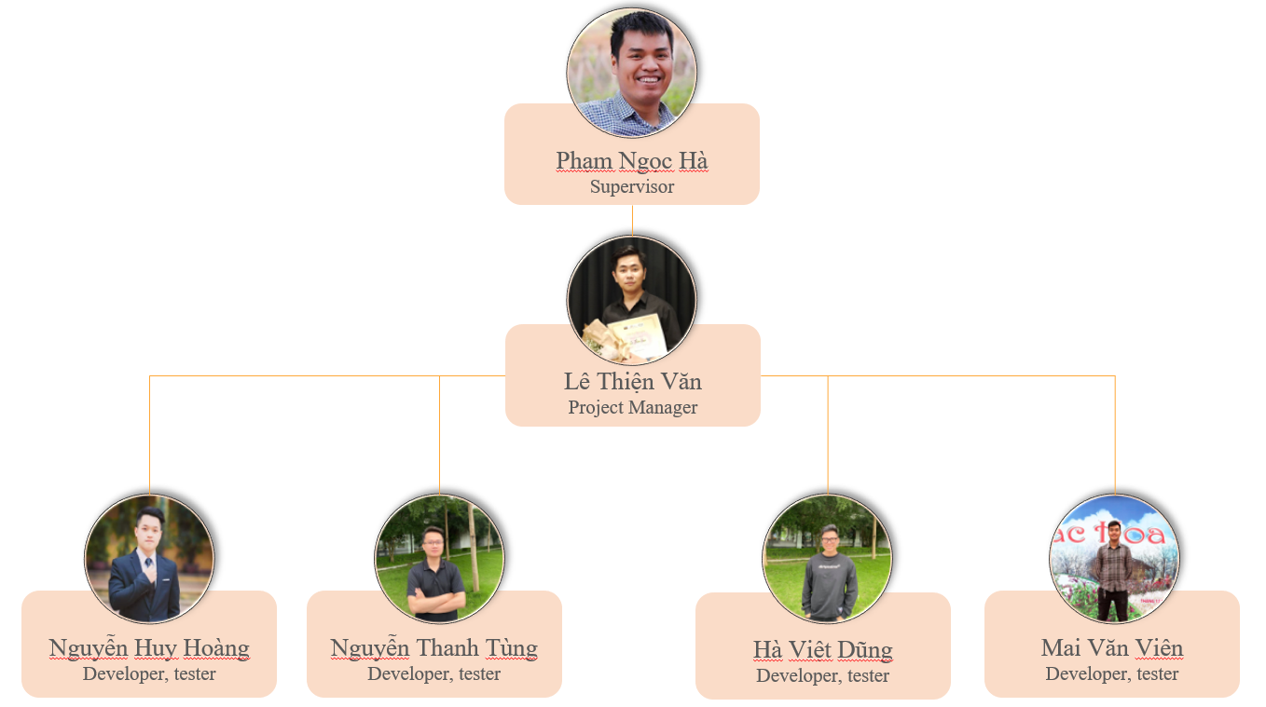

*Figure 2.2.2.1 – Project organization*

* 1. Role and responsibilities

|  |  |
| --- | --- |
| **Role** | **Responsibility** |
| Project Manager | Le Thien Van |
| Analysis Leader | Nguyen Huy Hoang |
| Analysis Member | Nguyen Thanh Tung, Mai Van Vien |
| Design Leader | Ha Viet Dung |
| Design Member | Le Thien Van |
| Technical Leader | Le Thien Van |
| Developer | Mai Van Vien, Ha Viet Dung, Nguyen Thanh Tung, Nguyen Huy Hoang |
| Test Leader | Mai Van Vien |
| Test Member | Nguyen Huy Hoang, Ha Viet Dung |

*Table 1.2.3.1 – Role and responsibilities*

* 1. Software process model

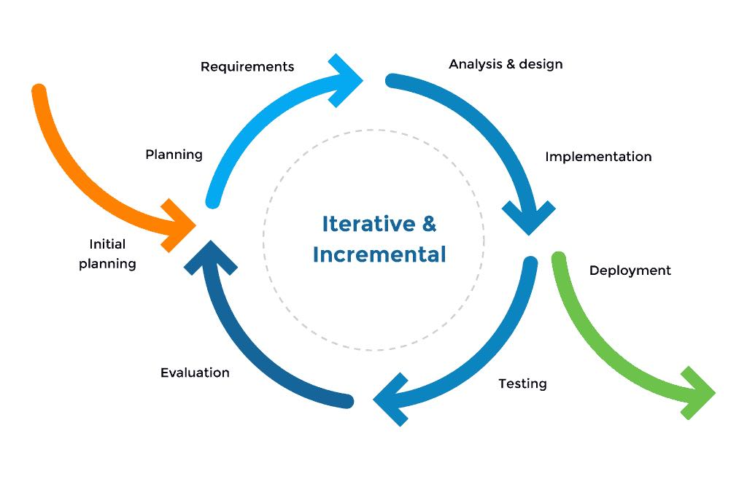

*Figure 2.2.4.1 – Iterative and incremental Model*

SOFA project uses the iterative and incremental model.

The iterative model feels like mini waterfalls chained together. Instead of designing and gathering the requirements for the whole applications, we slice the project into functional portions that progress through the waterfall steps. Also, this model has these useful advantages:

* You can develop prioritized requirements first.
* Initial product delivery is faster.
* Customers gets important functionality early.
* Lowers initial delivery cost.
* Each release is a product increment, so that the customer will have a working product at hand all the time.
* Customer can provide feedback to each product increment, thus avoiding surprises at the end of development.
* Requirements changes can be easily accommodated.

1. **Project management Plan**

|  |  |  |  |
| --- | --- | --- | --- |
| **No.** | **WBS Item** | **Complexity** | **Est. Effort (Man-days)** |
| **I** | **SOFA Project** |  | **375** |
| **1** | **Pre-Initiating Phase** |  | **5** |
| 1.1 | Select Project Manager | Simple | 1 |
| 1.2 | Determine the role of team member | Simple | 1 |
| 1.3 | Choose topic | Simple | 2 |
| 1.4 | Register capstone project | Simple | 1 |
| **2** | **Initiating phase** |  | **9** |
| 2.1 | Determine stakeholder | Medium | 1 |
| 2.2 | List up requirement | Simple | 2.5 |
| 2.3 | Define scope of project | Simple | 2.5 |
| 2.4 | Create report 1 - project introduction document | Medium | 2.5 |
| 2.6 | Modify project introduction document | Simple | 0.5 |
| **3** | **Project Plan Phase** |  | **8** |
| 3.1 | Choose working model process | Simple | 2.5 |
| 3.2 | Select tools and techniques | Simple | 0.5 |
| 3.3 | Create project schedule | Simple | 1 |
| 3.4 | Create risk management plan | Medium | 1 |
| 3.5 | Organize project resources | Simple | 2 |
| 3.6 | Create report 2 - software project management plan | Medium | 1 |
| **4** | **Executing Phase** |  | **346** |
| **4.1** | **Design** |  | **59.5** |
| 4.1.1 | List up use case | Simple | 1 |
| 4.1.2 | Create use case description | Medium | 1.5 |
| 4.1.3 | Create report 3 -Software requirement specification | Medium | 5 |
| 4.1.4 | Create Architecture design | Complex | 10 |
| 4.1.4.1 | Data Architecture design | Medium | 2 |
| 4.1.4.2 | Data flow architectures | Medium | 2 |
| 4.1.4.3 | Call and Return architectures | Medium | 2 |
| 4.1.4.4 | Object Oriented architecture | Medium | 2 |
| 4.1.4.5 | Layered architecture | Medium | 2 |
| 4.1.5 | Database design | Medium | 10 |
| 4.1.6 | GUI layout design | Complex | 25 |
| 4.1.7 | Create report 4 - Software design | Simple | 5 |
| 4.1.8 | Redesign use case | Simple | 2 |
| **4.2** | **Implementation** |  | **237** |
| 4.2.1 | Back-end (RESTful API) |  | 92 |
| 4.2.1.1 | Configuration and setup environment | Simple | 2 |
| 4.2.1.2 | Create database | Simple | 15 |
| 4.2.1.3 | Coding common, Middleware, DBContext | Medium | 5 |
| 4.2.1.4 | Coding Model and Data Access Object | Medium | 10 |
| 4.2.1.5 | Coding controller handler request of manager page | Complex | 25 |
| 4.2.1.6 | Coding controller handler request of user app | Complex | 35 |
| 4.2.2 | Front-end |  | 140 |
| 4.2.2.1 | SOFA Manager (Web flatform) | Complex | 40 |
| 4.2.2.2 | SOFA (Android app flatform) | Complex | 100 |
| 4.2.3 | Deploy |  | 5 |
| 4.2.3.1 | Deploy host and domain config | Medium | 5 |
| 4.3 | **Test** |  | **49** |
| 4.3.1 | Test manager website |  | 24 |
| 4.3.1.1 | Create test cases for unit test | Simple | 2 |
| 4.3.1.2 | Unit test | Simple | 2 |
| 4.3.1.3 | Fix bug | Medium | 2 |
| 4.3.1.4 | Create test cases for integration test | Simple | 2 |
| 4.3.1.5 | Integration test | Simple | 2 |
| 4.3.1.6 | Fix bug | Medium | 2 |
| 4.3.1.7 | Create test cases for system test | Simple | 2 |
| 4.3.1.8 | System test | Simple | 2 |
| 4.3.1.9 | Fix bug | Medium | 2 |
| 4.3.1.10 | Create test case for acceptance test | Simple | 2 |
| 4.3.1.11 | Acceptance test | Simple | 2 |
| 4.3.1.12 | Fix bug | Medium | 2 |
| 4.3.2 | Test user application |  | 24 |
| 4.3.2.1 | Create test cases for unit test | Simple | 2 |
| 4.3.2.2 | Unit test | Simple | 2 |
| 4.3.2.3 | Fix bug | Medium | 2 |
| 4.3.2.4 | Create test cases for integration test | Simple | 2 |
| 4.3.2.5 | Integration test | Simple | 2 |
| 4.3.2.6 | Fix bug | Medium | 2 |
| 4.3.2.7 | Create test cases for system test | Simple | 2 |
| 4.3.2.8 | System test | Simple | 2 |
| 4.3.2.9 | Fix bug | Medium | 2 |
| 4.3.2.10 | Create test case for acceptance test | Simple | 2 |
| 4.3.2.11 | Acceptance test | Simple | 2 |
| 4.3.2.12 | Fix bug | Medium | 2 |
| 4.3.3 | Summary and evaluation | Simple | 1 |
| 4.1.9 | Create report 5 - Test case document | Simple | 2.5 |
| 4.1.10 | Create report 6 - Software user guide | Simple | 2.5 |
| **4.4** | **Finish executing phase** |  | **0.5** |
| **5** | **Monitoring and controlling** |  | **2** |
| 5.1 | Progress report | Simple | 2 |
| **6** | **Close** |  | 5 |
| 6.1 | Create final report | Medium | 5 |
| 6.2 | Project complete | Simple | 0 |

*Table 2.3.1 – Project management plan*

1. **Meeting minutes**

|  |  |  |  |  |
| --- | --- | --- | --- | --- |
| **Communication Item** | **Who/ Target** | **Purpose** | **When, Frequency** | **Type, Tool, Method(s)** |
| Weekly meeting | Supervisor and team members | Review members’ work achievements during the week and report the project’s progress and status. | Every Tuesday | Face to face |
| Daily meeting | Team members | Report the progress that members achieved each day. | 21h,  every day | Google meet |
| Unscheduled Meeting | Team members | Occurred when there's a critical problem that need to be resolved immediately |  | Face to face, google meet |

*Table 2.4.1 – Meeting minutes*

1. **Risk management Plan**

|  |  |  |  |  |  |
| --- | --- | --- | --- | --- | --- |
| **No.** | **Risk** | **Description** | **Impact** | **Possibility** | **Response Plans** |
| 1 | Inaccurate Estimations | Schedule is inaccurate | Medium | Medium | 1) Create schedule carefully 2) Add backup time (or backup schedule) 3) Focus on close targets |
| 2 | Poor Quality Code | The code may be difficult to read, meaning it is difficult for other developers to review or make changes | High | Low | 1) Code reviews 2) Clear coding standards and guides 3) Testing of all code |
| 3 | Inadequate Human Resources | Don't have enough member to complete project be on time | Medium | Low | 1) Register overtime for team member |
| 4 | Technical Difficulties | Have issues during coding | Medium | Medium | 1) Choose design pattern appropriate 2) Create architecture design more detail and exactly 3) Have a professional in team |
| 5 | Security | The system is unsafe for user, hacker can attack and take user information… | High | High | 1) Using token for improving backend security 2) Add more algorithm for hash private information 3) Take preventive measures hacking |
| 6 | lack of requirement | Developer create code was not enough requirement | High | Medium | 1) Code reviews 2) Clear coding standards and guides 3) Testing of all code |

*Table 2.5.1 – Risk management plan*

1. **Document management Plan**

We use GitHub as our tool for sharing, editing and version control of our documents, along with Status Reports with-in each document. It allows us to see what is changed in the documents and who is responsible for that change, reverse and simultaneously compare between versions of the document.

1. **Source code management Plan**

For version control of our source code, we use GitHub. It tracks the changes team members make to files, so we have a record of what has been done, and we can revert to specific versions should we ever need to. GitHub also makes collaboration easier, allowing changes by multiple people to all be merged into one source.

GitHub also features branches that provide an isolated environment for every change to our codebase. When a team member wants to start working on something - no matter how big or small - he creates a new branch. This ensures that the master branch always contains production - quality code.

**Chapter 3: Software Requirement Specification**

1. **Purpose**

This chapter outlines functional and non-functional requirements of our system. It also provides some format constraints in common requirements and project success criteria. The content of this chapter is used as the basis for the work in the subsequent chapters.

1. **User requirements**
   1. Overview
2. Use case diagram

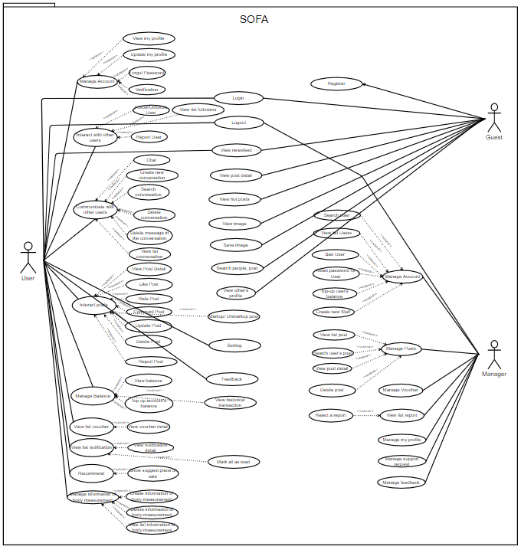

*Figure 3.2.1.1 – Usecase diagram*

1. System Actors

|  |  |  |
| --- | --- | --- |
| **#** | **Actor** | **Description** |
| 1 | Guest | The person who doesn’t have an account and not log in to the system |
| 2 | User | The person has an account and logs in |
| 3 | Manager | The person who manages the whole system, users, posts, reports, balance, and recommendation data. |

*Table 3.2.1.1 – System Actors*

1. Use Cases List

|  |  |  |  |
| --- | --- | --- | --- |
| **ID** | **Use Case** | **Actors** | **Use Case Description** |
| 01 | View newsfeed | Guest | Allow guests to view newsfeed but can’t react the post |
| 02 | Register | Guest | Allows guests to create an account for the system |
| 03 | Login | Guest | Allow user to login to the system |
| 04 | Search: Post, People | Guest | Allow user to search people and post by name |
| 05 | View other profile | Guest | Allow people to view other’s people profile |
| 06 | View post detail | Guest | Allow user to view post detail |
| 07 | View hot post | Guest | Allow people to view hot posts |
| 08 | View image | Guest | Allow people to view image in the post |
| 09 | Save image | Guest | Allow people to save image to local |
| 10 | Forgot password | User | Allows users to reset a new password after authenticating owning an account |
| 11 | Verification | User | Send OTP code for the user |
| 12 | Logout | User | Allows users log out from the application |
| 13 | View newsfeed | User | Allows app users to access newsfeeds and view posts |
| 14 | View post detail | User | View the detail content of the post |
| 15 | Like post | User | Allow user to like the post |
| 16 | Rate post | User | Allow user to rate the post from 1 to 5 star |
| 17 | Comment post | User | Allow user to comment in the post |
| 18 | Report post | User | Allow user to report the post with some reason which have been classified |
| 19 | Markup/Unmark up a post | User | Allow user to save the post |
| 20 | Create a post | User | Allow user to create a post and post it |
| 21 | Update post | User | Allow user to update their post |
| 22 | Delete post | User | Allow user to delete their post |
| 23 | Follow/ Unfollow users | User | Allow user to follow other users to see their post at the first of the newsfeed |
| 24 | Unfollow users | User | Allow user to unfollow other users |
| 26 | Report users | User | Allow user to report the user with some reason which have been classified |
| 27 | View other user’s profile | User | Allow user to view each other profile |
| 28 | Chat | User | Allow user to communicate with each other |
| 29 | Delete message in the conversation | User | Allow user to delete the message in the conversation with other user in their side or both side |
| 30 | Delete conversation | User | Allow user to delete one or many conversations |
| 31 | View list conversation | User | Allow user to view list of their conversation |
| 32 | Search a conversation | User | Allow user search to conversation by the name of the conversation |
| 33 | View my profile | User | Allow user to view their profile |
| 34 | Update my profile | User | Allow user to update their information then save it to their profile |
| 35 | Search people | User | Allow user to search others by their name |
| 36 | Search post | User | Allow user to search posts by their title, content, tag, caption |
| 37 | View image | User | Allow user to view Image |
| 38 | Save image | User | Allow user save image to local |
| 39 | Mark all as read | User | Allow user mark all notification as read |
| 40 | Create new conversation | User | Allow user to create a new conversation |
| 41 | Create information of body measurement | User | Allow user to create a new body measurement |
| 42 | Delete information of body measurement | User | Allow user to delete a body measurement |
| 43 | View historical transaction | User | Allow user to view historical transaction |
| 44 | View list markup posts | User | Allow user to view all markup posts |
| 45 | View list information of body measurement | User | Allow user to view list body measurement |
| 46 | Setting | User | Allow user to setting the system |
| 47 | Feedback | User | Allow user to send feedback |
| 48 | View list followers | User | Allow user to view list followers |
| 49 | View list notification | User | View top newest notification which user have received |
| 50 | View a notification | User | View a notification: when user click to the notification system will direct to another screen |
| 51 | View hot posts | User | View fashionista posts and high engagement articles |
| 52 | Recommend | User | Recommend posts based on a user's metrics |
| 53 | Show suggest place of sale | User | Show people who sell products |
| 54 | View balance | User | Allows users to view account balances, transaction history |
| 55 | Top up account | User | Allows users to top up the account |
| 56 | View list voucher | User | View list voucher which user have received |
| 57 | View voucher detail | User | Allow user to view detail content of a voucher |
| 58 | Login | Manager | Allow manager to login to the web server |
| 59 | Logout | Manager | Allow manager to logout from the web server |
| 60 | Create new staff | Manager | Admins with higher authority will be allowed to create accounts with smaller roles for system administration |
| 61 | View list user | Manager | Allow manager to view all user |
| 62 | Search user | Manager | Allow manager to search user by their name |
| 63 | Ban user | Manager | Allow manager to ban user |
| 64 | Reset password for user | Manager | Reset password for user when they can connect recovery password |
| 65 | View list post | Manager | Allow manager to view all user’s post |
| 66 | View post detail | Manager | Allow manager to view detail content of a post |
| 67 | Search user’s post | Manager | Allow manager to search posts by their title, content, tag, caption |
| 68 | Delete post | Manager | Allow manager to delete a post |
| 69 | Manage voucher | Manager | Allow manager to offer a voucher to users |
| 70 | View list report | Manager | Allow manager to view list report |
| 71 | View report detail | Manager | Allow manager to view report detail |
| 72 | Manage recommend data | Manager | See a list of articles that score enough points to be included in the recommend system |
| 73 | Top up user’s balance | Manager | Allow manager to top up or down user’s balance |
| 74 | Manage my profile | Manager | Allow manager to update their information then save it to their profile |
| 75 | View dashboard |  | Allow manager to view dashboard |
| 76 | View user detail | Manager | Allow manager to view user’s detail information |
| 77 | Reject report | Manager | Allow manager to reject a report |
| 78 | Manage Support Request | Manager | Allow manager to manage support request |
| 79 | Manage Feedback | Manager | Allow manager to manage feedback from user |

*Table 3.2.1.2 – Usecase list*

* 1. Feature for guest
     1. ***Use case 01 (Actor guest)***

|  |  |  |  |
| --- | --- | --- | --- |
| ID and Name: | **UC-01 View newsfeeds** | | |
|  |  | | |
| Created By: | Mai Văn Viên | Date Created: | 26/01/2021 |
| Primary Actor: | Guest | Secondary Actors: | None |
| Description: | An guest accesses the app from mobile phone view newsfeeds | | |
| Trigger: | An guest accesses the app from mobile phone and skip login | | |
| Preconditions: | None | | |
| Post-conditions: | View screen newsfeeds | | |
| Normal Flow: | 1. **Guest view newsfeeds**   1. The guest accesses the app from a mobile phone  2. The guest clicks “skip login”  3. Display screen newsfeeds | | |
| Alternative Flows: | None | | |
| Exceptions: | None | | |
| Priority: | Medium | | |
| Frequency of Use: | Average a guest view newsfeeds one time before register account in-app SOFA | | |
| Business Rules: | BR-21 | | |
| Other Information: | View post public sort by date decrease | | |
| Assumptions: | None | | |

1. ***Use case 02 (Actor guest)***

|  |  |  |  |
| --- | --- | --- | --- |
| ID and Name: | **UC-02 Register** | | |
| Created By: | Mai Văn Viên | Date Created: | 26/01/2021 |
| Primary Actor: | Guest | Secondary Actors: | None |
| Description: | When a guest wants to use the functions of the system, it is imperative that they register for an account | | |
| Trigger: | Guest clicks on the button “Register” on Home screen | | |
| Preconditions: | None | | |
| Post-conditions: | Guest submit to send information to the system | | |
| Normal Flow: | **1.0 Guest Register**   1. The guest accesses the app from a mobile phone 2. The guest clicks “register” 3. System displays screen register 4. The guest inputs email or mobile phone number and password to register an account on the app | | |
| Alternative Flows: | **1.0 Guest Register in screen “login”**   1. In screen “login” 2. The guest clicks “register” | | |
| Exceptions: | 1. User already exists 2. Email already exists 3. Phone number already exists 4. Password invalid 5. Phone number invalid 6. Email invalid | | |
| Priority: | High | | |
| Frequency of Use: | None | | |
| Business Rules: | BR-17, BR-18, BR-19 | | |
| Other Information: | 1. Use when the user does not have an account on the system 2. When successfully registered, the default role is the user | | |
| Assumptions: | None | | |

1. ***Use case 03 (Actor guest)***

|  |  |  |  |
| --- | --- | --- | --- |
| ID and Name: | **UC-03 Login** | | |
| Created By: | Mai Văn Viên | Date Created: | 26/01/2021 |
| Primary Actor: | Guest | Secondary Actors: | None |
| Description: | If the guest has an account register in-app, they can access the app from their mobile phone | | |
| Trigger: | Guest clicks on the button “Login” on Home screen | | |
| Preconditions: | Account must be register in app SOFA | | |
| Post-conditions: | Login to mobile app SOFA | | |
| Normal Flow: | **1.0 Guest login**   1. The guest accesses the app from a mobile phone 2. Guest clicks “Login” 3. System displays screen login 4. The guest inputs email or mobile phone number and password registered on the app | | |
| Alternative Flows: | **1.0 Guest login when comment post in new feed**   1. In the screen “new feed”, guest comment in post 2. Display screen “login” | | |
| Exceptions: | 1. User doesn't exist 2. Email doesn't exist 3. Phone number doesn't exist 4. User or password don’t correct | | |
| Priority: | High | | |
| Frequency of Use: | This use case happens very regularly | | |
| Business Rules: | BR17 | | |
| Other Information: | When successful login, the application will go to the newsfeed screen | | |
| Assumptions: | None | | |

2.3 Feature for user

**a) *Use case 04 (Actor User)***

|  |  |  |  |
| --- | --- | --- | --- |
| ID and Name: | **UC-04 Forgot password** | | |
| Created By: | Mai Văn Viên | Date Created: | 26/01/2021 |
| Primary Actor: | User | Secondary Actors: | None |
| Description: | When the user forgets the password to log in, the system will send OTP to their email or mobile phone number to reset the password in the system | | |
| Trigger: | Guest clicks on the button “Forgot password” on Home screen | | |
| Preconditions: | Email or mobile phone number must be registered in-app SOFA | | |
| Post-conditions: | Send new password to email or mobile phone number of the user | | |
| Normal Flow: | **1.0 User forgot password**   1. On Home screen, User clicks “login” 2. System displays screen login 3. User click “Forgot password” 4. System display screen forgot password 5. User input email or password to input field and submit 6. System sends a new password to email or phone number 7. Display screen “Verification” | | |
| Alternative Flows: | None | | |
| Exceptions: | 1. User doesn't exist 2. Email doesn't exist 3. Phone number doesn't exist | | |
| Priority: | High | | |
| Frequency of Use: | This use case happens sometimes when the user forgot the password | | |
| Business Rules: | BR-17, BR-18 | | |
| Other Information: | None | | |
| Assumptions: | None | | |

**b) *Use case 05 (Actor User)***

|  |  |  |  |
| --- | --- | --- | --- |
| ID and Name: | **UC-05 Verification** | | |
| Created By: | Mai Văn Viên | Date Created: | 26/01/2021 |
| Primary Actor: | User | Secondary Actors: | None |
| Description: | When the user registers on the app, the system will send one OTP to their email or phone number. User must input valid OTP to continue use functions of the app | | |
| Trigger: | None | | |
| Preconditions: | None | | |
| Post-conditions: | None | | |
| Normal Flow: | **1.0 User Verification**   1. After the user submit info in screen “Register” 2. System displays screen “Verification” 3. User input OTP and submit | | |
| Alternative Flows: | None | | |
| Exceptions: | 1. OTP incorrect 2. System don’t send OTP to email or phone number 3. Their email or phone number incorrect | | |
| Priority: | High | | |
| Frequency of Use: | None | | |
| Business Rules: | BR-17, BR-18 | | |
| Other Information: | None | | |
| Assumptions: | None | | |

**c) *Use case 06 (Actor User)***

|  |  |  |  |
| --- | --- | --- | --- |
| ID and Name: | **UC-03 Logout** | | |
| Created By: | Mai Văn Viên | Date Created: | 26/01/2021 |
| Primary Actor: | User | Secondary Actors: | None |
| Description: | User logs out of the app | | |
| Trigger: | User clicks on the button “Logout” | | |
| Preconditions: | User login the app | | |
| Post-conditions: | None | | |
| Normal Flow: | **1.0 User Logout**   1. In the menu, User clicks “Logout” | | |
| Alternative Flows: | **1.0 User Logout when change password**   1. In the screen “Profile”, User clicks “Change password” 2. User input all fields and submit 3. Display toast message “Change password success!” 4. User logout from session | | |
| Exceptions: | None | | |
| Priority: | Low | | |
| Frequency of Use: | None | | |
| Business Rules: | BR-17, BR-18, BR-20 | | |
| Other Information: | None | | |
| Assumptions: | None | | |

**d) *Use case 07 (Actor User)***

|  |  |  |  |
| --- | --- | --- | --- |
| ID and Name: | **UC-03 View newsfeed** | | |
| Created By: | Mai Văn Viên | Date Created: | 26/01/2021 |
| Primary Actor: | User | Secondary Actors: | None |
| Description: | User view list of post that other user-submitted to the system | | |
| Trigger: | None | | |
| Preconditions: | The user has successfully logged in to the system | | |
| Post-conditions: | None | | |
| Normal Flow: | **1.0 User views newsfeeds**   1. In the navigation bar, click tab “Newsfeed” | | |
| Alternative Flows: | **1.0 User views newsfeeds after login**   1. The guest accesses the app from a mobile phone 2. Guest clicks “Login” 3. System displays screen login 4. The guest inputs email or mobile phone number and password registered on the app and submit 5. Display screen newsfeeds | | |
| Exceptions: | None | | |
| Priority: | High | | |
| Frequency of Use: | This use case regularly happens and usage load for this use case is all day | | |
| Business Rules: | None | | |
| Other Information: | None | | |
| Assumptions: | None | | |

1. ***Use case 08 (Actor User)***

|  |  |  |  |
| --- | --- | --- | --- |
| ID and Name: | **UC-08 View post detail** | | |
| Created By: | Nguyễn Huy Hoàng | Date Created: | 26/01/2021 |
| Primary Actor: | User | Secondary Actors: | None |
| Description: | View the detail content of the post | | |
| Trigger: | An user accesses the app from mobile phone then click on the post on the newsfeed | | |
| Preconditions: | PRE-1. User have login into SOFA | | |
| Post-conditions: | POST-1. The post is now exist in the system | | |
| Normal Flow: | **1.0 View post detail**   1. In the navigation bar, click tab “Newsfeed” 2. Click on the post that you want to view detail | | |
| Alternative Flows: | **1.0 View post detail when user click on post notification**   1. In the navigation bar, click tab “Notification” 2. Click on the notification about the post that you want to view detail | | |
| Exceptions: | * The post had been deleted but user still can view it * The post had been updated but user still see the old version | | |
| Priority: | High | | |
| Frequency of Use: | This use case happen very regularly and usage load for this use case is all day | | |
| Business Rules: | None | | |
| Other Information: | None | | |
| Assumptions: | None | | |

1. ***Use case 09 (Actor User)***

|  |  |  |  |
| --- | --- | --- | --- |
| ID and Name: | **UC-09 Like post** | | |
| Created By: | Nguyễn Huy Hoàng | Date Created: | 26/01/2021 |
| Primary Actor: | User | Secondary Actors: | None |
| Description: | User like the post which they see | | |
| Trigger: | User click on the Like button on the post | | |
| Preconditions: | PRE-1. User have login into SOFA | | |
| Post-conditions: | POST-1. The post is now exist in the system | | |
| Normal Flow: | * 1. **User views a post**  1. User click on the Like button on the post | | |
| Alternative Flows: | None | | |
| Exceptions: | None | | |
| Priority: | High | | |
| Frequency of Use: | This use case happen very regularly and usage load for this use case is all day | | |
| Business Rules: | None | | |
| Other Information: | None | | |
| Assumptions: | None | | |

1. ***Use case 10 (Actor User)***

|  |  |  |  |
| --- | --- | --- | --- |
| ID and Name: | **UC-10 Rate post** | | |
| Created By: | Nguyễn Huy Hoàng | Date Created: | 26/01/2021 |
| Primary Actor: | User | Secondary Actors: | None |
| Description: | Allow user to rate the post from 1 to 5 star | | |
| Trigger: | User click on the Rate bar on the post | | |
| Preconditions: | PRE-1. User have login into SOFA | | |
| Post-conditions: | POST-1. The post is now exist in the system | | |
| Normal Flow: | * 1. **User views a post**  1. User click on the Rate bar from 1 to 5 on the post | | |
| Alternative Flows: | None | | |
| Exceptions: | None | | |
| Priority: | High | | |
| Frequency of Use: | This use case happen regularly and usage load for this use case is all day | | |
| Business Rules: | None | | |
| Other Information: | None | | |
| Assumptions: | None | | |

1. ***Use case 11 (Actor User)***

|  |  |  |  |
| --- | --- | --- | --- |
| ID and Name: | **UC-11 Comment post** | | |
| Created By: | Nguyễn Huy Hoàng | Date Created: | 26/01/2021 |
| Primary Actor: | User | Secondary Actors: | None |
| Description: | Allow user to leave a comment on the post | | |
| Trigger: | User input comment on the text field then enter | | |
| Preconditions: | PRE-1. User have login into SOFA | | |
| Post-conditions: | POST-1. The post is now exist in the system | | |
| Normal Flow: | * 1. **User views a post**  1. User input comment on the text field then enter | | |
| Alternative Flows: | None | | |
| Exceptions: | None | | |
| Priority: | High | | |
| Frequency of Use: | This use case happen regularly and usage load for this use case is all day | | |
| Business Rules: | BR-08 | | |
| Other Information: | None | | |
| Assumptions: | None | | |

1. ***Use case 12 (Actor User)***

|  |  |  |  |
| --- | --- | --- | --- |
| ID and Name: | **UC-12 Report post** | | |
| Created By: | Nguyễn Huy Hoàng | Date Created: | 26/01/2021 |
| Primary Actor: | User | Secondary Actors: | None |
| Description: | Allow user to report a post | | |
| Trigger: | When user choose a report button on the post | | |
| Preconditions: | PRE-1. User have login into SOFA | | |
| Post-conditions: | POST-1. The post is now exist in the system | | |
| Normal Flow: | * 1. **User views a post**  1. User click on the Report button on the post | | |
| Alternative Flows: | None | | |
| Exceptions: | None | | |
| Priority: | High | | |
| Frequency of Use: | This use case rarely happen and usage load for this use case is all day | | |
| Business Rules: | None | | |
| Other Information: | None | | |
| Assumptions: | None | | |

1. ***Use case 13 (Actor User)***

|  |  |  |  |
| --- | --- | --- | --- |
| ID and Name: | **UC-13 Markup** | | |
| Created By: | Nguyễn Huy Hoàng | Date Created: | 26/01/2021 |
| Primary Actor: | User | Secondary Actors: | None |
| Description: | Allow user to save the post and the post will be save in the user’s library | | |
| Trigger: | When user choose a save button on the post | | |
| Preconditions: | PRE-1. User have login into SOFA | | |
| Post-conditions: | POST-1. The post is now exist in the system | | |
| Normal Flow: | * 1. **User views a post**  1. User click on the Save button on the post | | |
| Alternative Flows: | None | | |
| Exceptions: | None | | |
| Priority: | High | | |
| Frequency of Use: | This use case sometimes happen and usage load for this use case is all day | | |
| Business Rules: | None | | |
| Other Information: | None | | |
| Assumptions: | None | | |

1. ***Use case 14 (Actor User)***

|  |  |  |  |
| --- | --- | --- | --- |
| ID and Name: | **UC-14 Post a post** | | |
| Created By: | Nguyễn Huy Hoàng | Date Created: | 26/01/2021 |
| Primary Actor: | User | Secondary Actors: | None |
| Description: | Allow user to post text and images the their profile | | |
| Trigger: | When user write a text and upload pictures then choose post | | |
| Preconditions: | PRE-1. User have login into SOFA | | |
| Post-conditions: | None | | |
| Normal Flow: | **1.0 User are in newsfeed tab**  1. User click on the Post button  2. User enter text then choose pictures to update  3. User choose post this post | | |
| Alternative Flows: | None | | |
| Exceptions: | None | | |
| Priority: | High | | |
| Frequency of Use: | This use case regularly happen and usage load for this use case is all day | | |
| Business Rules: | BR-08, BR-09 | | |
| Other Information: | None | | |
| Assumptions: | None | | |

1. ***Use case 15 (Actor User)***

|  |  |  |  |
| --- | --- | --- | --- |
| ID and Name: | **UC-15 Update a post** | | |
| Created By: | Nguyễn Huy Hoàng | Date Created: | 26/01/2021 |
| Primary Actor: | User | Secondary Actors: | None |
| Description: | Allow user to update their post | | |
| Trigger: | When user write a text and upload pictures then choose post | | |
| Preconditions: | PRE-1. User have login into SOFA | | |
| Post-conditions: | POST-1. The post is now existing in the system  POST-2. The post is owned by it user | | |
| Normal Flow: | **1.0 User are in their profile tab**  1. User choose the post they want to update  2. User click on the button update  3. User update this post then click Save | | |
| Alternative Flows: | None | | |
| Exceptions: | None | | |
| Priority: | High | | |
| Frequency of Use: | This use case sometimes happen and usage load for this use case is all day | | |
| Business Rules: | BR-08, BR-09 | | |
| Other Information: | None | | |
| Assumptions: | None | | |

1. ***Use case 16 (Actor User)***

|  |  |  |  |
| --- | --- | --- | --- |
| ID and Name: | **UC-16 Delete a post** | | |
| Created By: | Nguyễn Huy Hoàng | Date Created: | 26/01/2021 |
| Primary Actor: | User | Secondary Actors: | None |
| Description: | Allow user to delete their post | | |
| Trigger: | When user click on the button Delete on the post | | |
| Preconditions: | PRE-1. User have login into SOFA | | |
| Post-conditions: | POST-1. The post is now existing in the system  POST-2. The post is owned by it user | | |
| Normal Flow: | **1.0 User are in their profile tab**  1. User choose the post they want to delete  2. User click on the Delete button  3. User click Yes to confirm delete this post | | |
| Alternative Flows: | None | | |
| Exceptions: | None | | |
| Priority: | High | | |
| Frequency of Use: | This use case sometimes happen and usage load for this use case is all day | | |
| Business Rules: | None | | |
| Other Information: | None | | |
| Assumptions: | None | | |

1. ***Use case 17 (Actor User)***

|  |  |  |  |
| --- | --- | --- | --- |
| ID and Name: | **UC-17 Follow up Users** | | |
| Created By: | Hà Việt Dũng | Date Created: | 26/01/2021 |
| Primary Actor: | User | Secondary Actors: | None |
| Description: | An User accesses the app from mobile phone, chooses another user and decides to follow him/her | | |
| Trigger: | An User indicates that he/she wants to follow an other's account | | |
| Preconditions: | PRE-1. User logged into SOFA. | | |
| Post-conditions: | POST-1. The person who wants to follow someone is not being blocked by the other person.  POST-2. Account of user who uses this use case is not being banned  POST-3. The followed person’s account is not being banned  POST-4. Number of people who followed the person has not exceeded the limit | | |
| Normal Flow: | **1.0 Follow up a person without permission necessary.**   1. A User accesses another user’s profile 2. The user sends a follow-up request to the other. (see 1.0. E1) 3. Follow successfully | | |
| Alternative Flows: | **1.1 Follow up a person with permission necessary**  Step 1,2 of normal flow  The followed user see the follow-up request (see 1.1.E1) | | |
| Exceptions: | **1.0. E1 Number of people who followed the person has exceeded the limit**  1. The followed person has too many followers  2. The follow-up request is not sent to the followed person  **1.1. E1 The followed person decides not to accept the request**  1a. If the followed user accepts the request, the return to step 3 of normal flow  1b. Else if the followed user declines the request, the SOFA terminates use case. | | |
| Priority: | Medium | | |
| Frequency of Use: | Average a person follow-ups 3-5 people per day. Usage load for this use case is all day | | |
| Business Rules: | BR-01, BR-20 | | |
| Other Information: | 1. Each person can see who is following him/her and the people whom he/she is following.  2. Number of followers can be shown in everyone’s profile if he/she wants. | | |
| Assumptions: | Assume that a person will follow 100 users and be followed by 100 users. | | |

***o) Use case 18 (Actor User)***

|  |  |  |  |
| --- | --- | --- | --- |
| ID and Name: | **UC-18 Unfollow up Users** | | |
| Created By: | Hà Việt Dũng | Date Created: | 26/01/2021 |
| Primary Actor: | User | Secondary Actors: | None |
| Description: | An User accesses the app from mobile phone, chooses an other user whom he/she is following and decides to unfollow. | | |
| Trigger: | An User indicates that he/she wants to unfollow an other's account | | |
| Preconditions: | PRE-1. User logged into SOFA. | | |
| Post-conditions: | POST-1. User is following at least 1 person.  POST-2. Account of user who uses this use case is not being banned | | |
| Normal Flow: | 1. **Unfollow a person’s account**   1. An User accesses another user’s profile who he/she is following  2. The user selects Unfollow  3. Unfollow successfully | | |
| Alternative Flows: | **None** | | |
| Exceptions: | **None** | | |
| Priority: | Medium | | |
| Frequency of Use: | Average a person unfollows 1,2 people per day. Usage load for this use case is all day | | |
| Business Rules: | BR-01, BR-20 | | |
| Other Information: | None | | |
| Assumptions: | Assume that a person will unfollow 10 users and be unfollowed by 10 users. | | |

***p) Use case 19 (Actor User)***

|  |  |  |  |
| --- | --- | --- | --- |
| ID and Name: | **UC-19 Block users** | | |
| Created By: | Hà Việt Dũng | Date Created: | 26/01/2021 |
| Primary Actor: | User | Secondary Actors: | None |
| Description: | An User accesses the app from mobile phone, chooses another user and decides to block him/her | | |
| Trigger: | An User indicates that he/she wants to block an other's account | | |
| Preconditions: | PRE-1. User logged into SOFA. | | |
| Post-conditions: | POST-1. Account of user who uses this use case is not being banned | | |
| Normal Flow: | 1. **Block a person’s account**   1. An User accesses another user’s profile  2. The user selects Block  3. User confirms her/his decision (see 1.0. E1)  4. Block successfully | | |
| Alternative Flows: | **None** | | |
| Exceptions: | **1.0. E1 User want to cancel decision**  1. If user cancel block decision, the SOFA terminates use case. | | |
| Priority: | Medium | | |
| Frequency of Use: | Average a person blocks 2,3 people per week. Usage load for this use case is all day | | |
| Business Rules: | BR-01, BR-20 | | |
| Other Information: | Each person can see the people whom he/she is blocking. | | |
| Assumptions: | Assume that a person will block 10 users and be blocked by 5 users. | | |

***q) Use case 20 (Actor user)***

|  |  |  |  |
| --- | --- | --- | --- |
| ID and Name: | **UC-20 Report users** | | |
| Created By: | Hà Việt Dũng | Date Created: | 26/01/2021 |
| Primary Actor: | User | Secondary Actors: | None |
| Description: | An User accesses the app from mobile phone, chooses another user and decides to report him/her | | |
| Trigger: | An User indicates that he/she wants to report an other's account because of some reasons | | |
| Preconditions: | PRE-1. User logged into SOFA. | | |
| Post-conditions: | POST-1. Account of user who uses this use case is not being banned | | |
| Normal Flow: | 1. **Report a person’s account**   1. An User accesses another user’s profile  2. The user selects Report  3. Choose (a) reason(s) why  4. User confirms her/his decision (see 1.0. E1)  5. Block successfully | | |
| Alternative Flows: | **None** | | |
| Exceptions: | **1.0. E1 User want to cancel decision**  1. If user cancel report decision, the SOFA terminates use case. | | |
| Priority: | High | | |
| Frequency of Use: | Average a person reports 1 people per week. Usage load for this use case is all day | | |
| Business Rules: | BR-01, BR-20 | | |
| Other Information: | Each person can see the people whom he/she reported. | | |
| Assumptions: | Assume that a person will report 2 users. | | |

***r) Use case 21 (Actor user)***

|  |  |  |  |
| --- | --- | --- | --- |
| ID and Name: | **UC-21 View others’ profile** | | |
| Created By: | Hà Việt Dũng | Date Created: | 26/01/2021 |
| Primary Actor: | User | Secondary Actors: | None |
| Description: | An User accesses the app from mobile phone, chooses another user to view his/her profile | | |
| Trigger: | An User indicates to view an other's profile. | | |
| Preconditions: | PRE-1. User logged into SOFA. | | |
| Post-conditions: | POST-1. The person who wants to view someone’s profile is not being blocked by the other person.  POST-2. Account of user who uses this use case is not being banned | | |
| Normal Flow: | 1. **View other people’s profile**   1. An User choose another user  2. Select View Profile (see 1.0.E1) | | |
| Alternative Flows: | **None** | | |
| Exceptions: | **1.0. E1. The user whose account is viewed select to lock his/her account**  1. Notice to the viewer  2. SOFA terminates the use case | | |
| Priority: | Medium | | |
| Frequency of Use: | Average a person views 5-10 people’s profile per day. Usage load for this use case is all day | | |
| Business Rules: | BR-01, BR-20 | | |
| Other Information: | 1. Information that is displayed in someone’s profile is chosen by the owner. | | |
| Assumptions: | Assume that a person will view 1000 users’ profile. | | |

**s) Use case 22 (Actor User)**

|  |  |  |  |
| --- | --- | --- | --- |
| ID and Name: | **UC-22 Chat with other users** | | |
| Created By: | Hà Việt Dũng | Date Created: | 26/01/2021 |
| Primary Actor: | User | Secondary Actors: | None |
| Description: | An User accesses the app from mobile phone, chooses another user to chat with him/her | | |
| Trigger: | An User indicates to chat with an other people. | | |
| Preconditions: | PRE-1. User logged into SOFA. | | |
| Post-conditions: | POST-1. The person who wants to chat with someone is not being blocked by the other person.  POST-2. Account of user who uses this use case is not being banned | | |
| Normal Flow: | 1. **Chat with someone**   1. An User choose another user  2. Select Chat  3. Type something or choose an image  4. Select Send (see 1.0.E1) | | |
| Alternative Flows: | N/A | | |
| Exceptions: | **1.0. E1. The file size of image that user want to send is too large**  1. Notice to the viewer  2. Return to step 3 of normal flow | | |
| Priority: | High | | |
| Frequency of Use: | Average a person chat with 10 people per day. Usage load for this use case is all day | | |
| Business Rules: | BR-01, BR-20 | | |
| Other Information: | 1. User can see the messages which he/she chatted.  2. User can see a list of people whom he/she chatted with | | |
| Assumptions: | Assume that a person will chat with 1000 users. | | |

***t) Use case 23 (Actor user)***

|  |  |  |  |
| --- | --- | --- | --- |
| ID and Name: | **UC-23 Delete message in conversation** | | |
| Created By: | Hà Việt Dũng | Date Created: | 26/01/2021 |
| Primary Actor: | User | Secondary Actors: | None |
| Description: | An User accesses the app from mobile phone, choose Message, enter an conversation, select a message that he/she want to delete | | |
| Trigger: | An User indicates to delete a message in conversation. | | |
| Preconditions: | PRE-1. User logged into SOFA. | | |
| Post-conditions: | POST-1. User who uses this use case chatted with someone.  POST-2. Account of user who uses this use case is not being banned | | |
| Normal Flow: | **1.0. Delete message in conversation**  1. An User chooses Message  2. Select a conversation  3. Select a message  4. Choose type of delete (Erase or Withdraw)  5. Confirm Delete (see 1.0. E1)  6. Delete finish | | |
| Alternative Flows: | N/A | | |
| Exceptions: | **1.0. E1. User want to cancel decision**  1. If user cancel delete decision, the SOFA terminates use case. | | |
| Priority: | High | | |
| Frequency of Use: | Average a person deletes 3-5 messages per weeks. Usage load for this use case is all day | | |
| Business Rules: | BR-01, BR-20 | | |
| paOther Information: | 1. If user chooses “Erase”, the other person still see the message.  2. If user chooses “With draw”, both people can’t see the message anymore. | | |
| Assumptions: | Assume that a person will delete about 200 messages. | | |

***u) Use case 24 (Actor user)***

|  |  |  |  |
| --- | --- | --- | --- |
| ID and Name: | **UC-24 Delete conversation** | | |
| Created By: | Hà Việt Dũng | Date Created: | 26/01/2021 |
| Primary Actor: | User | Secondary Actors: | None |
| Description: | An User accesses the app from mobile phone, choose Message, choose an conversation that he/she want to delete | | |
| Trigger: | An User indicates to delete a conversation. | | |
| Preconditions: | PRE-1. User logged into SOFA. | | |
| Post-conditions: | POST-1. User who uses this use case chatted with someone.  POST-2. Account of user who uses this use case is not being banned | | |
| Normal Flow: | **1.0. Delete conversation**  1. An User chooses Message  2. Select a conversation  3. Choose Delete  4. Confirm Delete (see 1.0. E1)  5. Delete finish | | |
| Alternative Flows: | N/A | | |
| Exceptions: | **1.0. E1. User want to cancel decision**  1. If user cancel delete decision, the SOFA terminates use case. | | |
| Priority: | High | | |
| Frequency of Use: | Average a person deletes 1 messages per weeks. Usage load for this use case is all day | | |
| Business Rules: | BR-01, BR-20 | | |
| Other Information: | 1. If user Delete a conversation, the other person still see this conversation. | | |
| Assumptions: | Assume that a person will delete about 20 conversation. | | |

***v) Use case 25 (Actor User)***

|  |  |  |  |
| --- | --- | --- | --- |
| ID and Name: | **UC-25 View list of conversations** | | |
| Created By: | Hà Việt Dũng | Date Created: | 26/01/2021 |
| Primary Actor: | User | Secondary Actors: | None |
| Description: | A User accesses the app from mobile phone, choose Message to view list of conversations. | | |
| Trigger: | An User indicates to view list of conversations. | | |
| Preconditions: | PRE-1. User logged into SOFA. | | |
| Post-conditions: | POST-1. User who uses this use case chatted with someone.  POST-2. Account of user who uses this use case is not being banned | | |
| Normal Flow: | **1.0. View list of conversations**  1. An User chooses Message  2. View a list of conversations | | |
| Alternative Flows: | **None** | | |
| Exceptions: | **None** | | |
| Priority: | High | | |
| Frequency of Use: | Average a person view list conversation 10 times per day. Usage load for this use case is all day | | |
| Business Rules: | BR-01, BR-20 | | |
| Other Information: | 1. List of conversation is sorted by time of latest message | | |
| Assumptions: | None | | |

***w) Use case 26 (Actor User)***

|  |  |  |  |
| --- | --- | --- | --- |
| ID and Name: | **UC-26 Search conversation** | | |
| Created By: | Hà Việt Dũng | Date Created: | 26/01/2021 |
| Primary Actor: | User | Secondary Actors: | None |
| Description: | A User accesses the app from mobile phone, choose Message, type something in Search Box to search conversation. | | |
| Trigger: | An User indicates to search conversation by name of other users. | | |
| Preconditions: | PRE-1. User logged into SOFA. | | |
| Post-conditions: | POST-1. User who uses this use case chatted with someone.  POST-2. Account of user who uses this use case is not being banned | | |
| Normal Flow: | **1.0. Search conversation**  1. An User chooses Message  2. Type something into Search Box to search (See 1.0. E1)  3. View result list of conversations | | |
| Alternative Flows: | **None** | | |
| Exceptions: | **1.0. E1 User don’t enter anything into Search Box**  **1. Notice for user**  **2. SOFA terminate the use case** | | |
| Priority: | Medium | | |
| Frequency of Use: | Average a person search conversation 3-5 times per week. Usage load for this use case is all day | | |
| Business Rules: | BR-01, BR-20 | | |
| Other Information: | None | | |
| Assumptions: | None | | |

***x) Use case 27 (Actor User)***

|  |  |  |  |
| --- | --- | --- | --- |
| ID and Name: | **UC-27 View my profile** | | |
| Created By: | Hà Việt Dũng | Date Created: | 26/01/2021 |
| Primary Actor: | User | Secondary Actors: | None |
| Description: | An User accesses the app from mobile phone, choose Profile to view | | |
| Trigger: | An User indicates to view his/her profile. | | |
| Preconditions: | PRE-1. User logged into SOFA. | | |
| Post-conditions: | POST-1. Account of user who uses this use case is not being banned | | |
| Normal Flow: | **1.0. Search conversation**  1. An User chooses Profile  2. Display profile | | |
| Alternative Flows: | **None** | | |
| Exceptions: | **None** | | |
| Priority: | Medium | | |
| Frequency of Use: | Average a person view his/her profile 1-2 times per day. Usage load for this use case is all day | | |
| Business Rules: | BR-01, BR-20 | | |
| Other Information: | None | | |
| Assumptions: | None | | |

***y) Use case 28 (Actor User)***

|  |  |  |  |
| --- | --- | --- | --- |
| ID and Name: | **UC-28 Update my profile** | | |
| Created By: | Hà Việt Dũng | Date Created: | 26/01/2021 |
| Primary Actor: | User | Secondary Actors: | None |
| Description: | An User accesses the app from mobile phone, choose Profile to update | | |
| Trigger: | An User indicates to update his/her profile. | | |
| Preconditions: | PRE-1. User logged into SOFA. | | |
| Post-conditions: | POST-1. Account of user who uses this use case is not being banned | | |
| Normal Flow: | **1.0. Search conversation**  1. An User chooses Profile  2. Display profile  3. Choose update  4. Enter information that he/she wants to update  5. Choose Save (see 1.0. E1)  6. Update successfully | | |
| Alternative Flows: | **None** | | |
| Exceptions: | **1.0. E1. Some information is wrong format**  **1. Notice user for correct**  **2. Direct to the info which is wrong for user to correct** | | |
| Priority: | Medium | | |
| Frequency of Use: | Average a person view his/her profile 1-2 times per day. Usage load for this use case is all day | | |
| Business Rules: | BR-01, BR-20 | | |
| Other Information: | None | | |
| Assumptions: | None | | |

***z) Use case 29 (Actor User)***

|  |  |  |  |
| --- | --- | --- | --- |
| ID and Name: | **UC-29 Search people** | | |
| Created By: | Hà Việt Dũng | Date Created: | 26/01/2021 |
| Primary Actor: | User | Secondary Actors: | None |
| Description: | A User accesses the app from mobile phone, type something in Search Box to search people. | | |
| Trigger: | An User indicates to search other users by name. | | |
| Preconditions: | PRE-1. User logged into SOFA. | | |
| Post-conditions: | POST-1. Account of user who uses this use case is not being banned | | |
| Normal Flow: | **1.0. Search other users**  1. Type something into Search Box to search (See 1.0. E1)  2. View result list of other users | | |
| Alternative Flows: | **None** | | |
| Exceptions: | **1.0. E1 User don’t enter anything into Search Box**  **1. Notice for user**  **2. SOFA terminate the use case** | | |
| Priority: | Medium | | |
| Frequency of Use: | Average a person search other users 1-2 times per day. Usage load for this use case is all day | | |
| Business Rules: | BR-01, BR-20 | | |
| Other Information: | Result list of searched people is sorted by interaction level. | | |
| Assumptions: | None | | |

***aa) Use case 30 (Actor User)***

|  |  |  |  |
| --- | --- | --- | --- |
| ID and Name: | **UC-30 Search posts** | | |
| Created By: | Hà Việt Dũng | Date Created: | 26/01/2021 |
| Primary Actor: | User | Secondary Actors: | None |
| Description: | A User accesses the app from mobile phone, type something in Search Box to search posts. | | |
| Trigger: | An User indicates to search posts. | | |
| Preconditions: | PRE-1. User logged into SOFA. | | |
| Post-conditions: | POST-1. Account of user who uses this use case is not being banned | | |
| Normal Flow: | **1.0. Search other users**  1. Type something into Search Box to search (See 1.0. E1)  2. Switch into Post to search posts  3. View result list of posts | | |
| Alternative Flows: | **None** | | |
| Exceptions: | **1.0. E1 User don’t enter anything into Search Box**  **1. Notice for user**  **2. SOFA terminate the use case** | | |
| Priority: | Medium | | |
| Frequency of Use: | Average a person search other users 1-2 times per day. Usage load for this use case is all day | | |
| Business Rules: | BR-01, BR-20 | | |
| Other Information: | Posts can be search by content, title, tag, caption,… | | |
| Assumptions: | None | | |

***ab) Use case 31 (Actor User)***

|  |  |  |  |
| --- | --- | --- | --- |
| ID and Name: | **UC-31 View list of notifications** | | |
| Created By: | Hà Việt Dũng | Date Created: | 26/01/2021 |
| Primary Actor: | User | Secondary Actors: | None |
| Description: | A User accesses the app from mobile phone, choose Notification to view list of notifications. | | |
| Trigger: | An User indicates to view list of notifications. | | |
| Preconditions: | PRE-1. User logged into SOFA. | | |
| Post-conditions: | POST-1. Account of user who uses this use case is not being banned | | |
| Normal Flow: | **1.0. View list of notifications**  1. An User chooses Notification  2. View a list of conversations | | |
| Alternative Flows: | **None** | | |
| Exceptions: | **None** | | |
| Priority: | Medium | | |
| Frequency of Use: | Average a person view list notification 10 times per day. Usage load for this use case is all day | | |
| Business Rules: | BR-01, BR-20 | | |
| Other Information: | 1. List of conversation is sorted by time of latest notification | | |
| Assumptions: | Each user views notification list about 1000 times | | |

***ac) Use case 32 (Actor User)***

|  |  |  |  |
| --- | --- | --- | --- |
| ID and Name: | **UC-32 View a notifications** | | |
| Created By: | Hà Việt Dũng | Date Created: | 26/01/2021 |
| Primary Actor: | User | Secondary Actors: | None |
| Description: | A User accesses the app from mobile phone, choose Notification and select a notification to view. | | |
| Trigger: | An User indicates to view a notification. | | |
| Preconditions: | PRE-1. User logged into SOFA. | | |
| Post-conditions: | POST-1. Account of user who uses this use case is not being banned  POST-2. Account has at least 1 notification | | |
| Normal Flow: | **1.0. View list of notifications**  1. An User chooses Notification  2. View a list of conversations  3. Select an notification to view (see 1.0. E1)  4. Direct to the post of notification | | |
| Alternative Flows: | **None** | | |
| Exceptions: | **1.0. E1 The post of notification is deleted**  **1. Notice user**  **2. SOFA terminate use case** | | |
| Priority: | Medium | | |
| Frequency of Use: | Average a person view a notification 15 times per day. Usage load for this use case is all day | | |
| Business Rules: | BR-01, BR-20 | | |
| Other Information: | None | | |
| Assumptions: | Each user a notification about 3000 times | | |

***ad) Use case 33 (Actor User)***

|  |  |  |  |
| --- | --- | --- | --- |
| ID and Name: | **UC-33 View hot posts** | | |
| Created By: | Hà Việt Dũng | Date Created: | 26/01/2021 |
| Primary Actor: | User | Secondary Actors: | None |
| Description: | A User accesses the app from mobile phone, choose HOT tab to view list of hot posts. | | |
| Trigger: | An User indicates to view list of hot posts. | | |
| Preconditions: | PRE-1. User logged into SOFA. | | |
| Post-conditions: | POST-1. Account of user who uses this use case is not being banned | | |
| Normal Flow: | **1.0. View list of hot post**  1. An User chooses HOT tab  2. Display list of hot post | | |
| Alternative Flows: | **None** | | |
| Exceptions: | **None** | | |
| Priority: | Medium | | |
| Frequency of Use: | Average a person view list of hot posts 5-10 times per day. Usage load for this use case is all day | | |
| Business Rules: | BR-01, BR-20 | | |
| Other Information: | 1. Hot posts is the posts which belongs to fashionista or are the most popular post. | | |
| Assumptions: | Each user views list hot posts about 1000 times | | |

***ae) Use case 34 (Actor User)***

|  |  |  |  |
| --- | --- | --- | --- |
| ID and Name: | **UC-34 View recommended posts** | | |
| Created By: | Hà Việt Dũng | Date Created: | 26/01/2021 |
| Primary Actor: | User | Secondary Actors: | None |
| Description: | An User accesses the app from mobile phone, choose Recommend tab to view list of recommended posts. | | |
| Trigger: | An User indicates to view list of recommended posts. | | |
| Preconditions: | PRE-1. User logged into SOFA. | | |
| Post-conditions: | POST-1. Account of user who uses this use case is not being banned | | |
| Normal Flow: | **1.0. View list of hot post**  1. An User chooses Recommend tab  2. Display list of recommened posts | | |
| Alternative Flows: | **None** | | |
| Exceptions: | **None** | | |
| Priority: | Medium | | |
| Frequency of Use: | Average a person view list of hot posts 5-10 times per day. Usage load for this use case is all day | | |
| Business Rules: | BR-01, BR-20 | | |
| Other Information: | 1. Recommended posts is the posts which is suitable with each users by measurements | | |
| Assumptions: | Each user views list recommended posts about 2000 times | | |

***af) Use case 35 (Actor User)***

|  |  |  |  |
| --- | --- | --- | --- |
| ID and Name: | **UC-35 Show suggest place of sale** | | |
| Created By: | Hà Việt Dũng | Date Created: | 26/01/2021 |
| Primary Actor: | User | Secondary Actors: | None |
| Description: | An User accesses the app from mobile phone, choose a post, select a product to see suggested place of sale | | |
| Trigger: | An User indicates to see where to buy a product. | | |
| Preconditions: | PRE-1. User logged into SOFA. | | |
| Post-conditions: | POST-1. Account of user who uses this use case is not being banned | | |
| Normal Flow: | **1.0. Show suggest place of sale of a product**  1. An User chooses a post  2. Select product in post  3. Display a list of place where sale the product | | |
| Alternative Flows: | **None** | | |
| Exceptions: | **None** | | |
| Priority: | Medium | | |
| Frequency of Use: | Average a person view suggested place of sale 10 times per day. Usage load for this use case is all day | | |
| Business Rules: | BR-01, BR-20 | | |
| Other Information: | If in database this is no place sale the product, the list is empty. | | |
| Assumptions: | Each user views suggested place of sale about 500 times | | |

***ag) Use case 36 (Actor User)***

|  |  |  |  |
| --- | --- | --- | --- |
| ID and Name: | **UC-36 View Balance** | | |
| Created By: | Mai Văn Viên | Date Created: | 26/01/2021 |
| Primary Actor: | User | Secondary Actors: | None |
| Description: | User views balance and history transaction | | |
| Trigger: | None | | |
| Preconditions: | User has successfully logged in to the system | | |
| Post-conditions: | None | | |
| Normal Flow: | **1.0 User view balance**   1. In the screen “Profile”, user click “ Manage balance” | | |
| Alternative Flows: | None | | |
| Exceptions: | None | | |
| Priority: | High | | |
| Frequency of Use: | This use case sometimes happens and usage load for this use case is all day | | |
| Business Rules: | None | | |
| Other Information: | None | | |
| Assumptions: | None | | |

***ah) Use case 37 (Actor User)***

|  |  |  |  |
| --- | --- | --- | --- |
| ID and Name: | **UC-37 Top up account** | | |
| Created By: | Mai Văn Viên | Date Created: | 26/01/2021 |
| Primary Actor: | User | Secondary Actors: | None |
| Description: | User add more money to the account | | |
| Trigger: | None | | |
| Preconditions: | User has successfully logged in to the system | | |
| Post-conditions: | Balance of user up | | |
| Normal Flow: | **1.0 Top up account**   1. In the menu, the user clicks “Top up account” 2. System display screen “Top-up” 3. User enters “PIN code” and “Scratch card no” | | |
| Alternative Flows: | None | | |
| Exceptions: | None | | |
| Priority: | High | | |
| Frequency of Use: | This use case sometimes happens and usage load for this use case is all day | | |
| Business Rules: | BR-17, BR-18 | | |
| Other Information: | None | | |
| Assumptions: | None | | |

***ai) Use case 38 (Actor User)***

|  |  |  |  |
| --- | --- | --- | --- |
| ID and Name: | **UC-38 View list voucher** | | |
| Created By: | Mai Văn Viên | Date Created: | 26/01/2021 |
| Primary Actor: | User | Secondary Actors: | None |
| Description: | When user views a list of all voucher, they can see the number of vouchers in their account | | |
| Trigger: | View all voucher in account | | |
| Preconditions: | User has successfully logged in to the system | | |
| Post-conditions: | View all voucher in account | | |
| Normal Flow: | **1.0 View list voucher**   1. In the menu, user click “Manage voucher” 2. System displays all voucher of account | | |
| Alternative Flows: | None | | |
| Exceptions: |  | | |
| Priority: | Low | | |
| Frequency of Use: | This use case sometimes happens and usage load for this use case is all day | | |
| Business Rules: | None | | |
| Other Information: | None | | |
| Assumptions: | None | | |

***aj) Use case 39 (Actor User)***

|  |  |  |  |
| --- | --- | --- | --- |
| ID and Name: | **UC-36 View voucher detail** | | |
| Created By: | Mai Văn Viên | Date Created: | 26/01/2021 |
| Primary Actor: | User | Secondary Actors: | None |
| Description: | When the user views a list of all vouchers, they can see the number of vouchers in their account. When they click on one voucher, the system will redirect to a new screen to show these voucher details | | |
| Trigger: | View details of one voucher | | |
| Preconditions: | User has successfully logged in to the system | | |
| Post-conditions: | View details of one voucher | | |
| Normal Flow: | **1.0 View list voucher**   1. In the menu, the user clicks “Manage voucher” 2. System displays all voucher of account 3. User clicks once voucher 4. System displays voucher details | | |
| Alternative Flows: | None | | |
| Exceptions: | This use case sometimes happens and usage load for this use case is all day | | |
| Priority: | High | | |
| Frequency of Use: | None | | |
| Business Rules: | None | | |
| Other Information: | None | | |
| Assumptions: | None | | |

2.4 Feature for manager

a. Login

|  |  |  |  |
| --- | --- | --- | --- |
| ID and Name: | **UC-40 Login for Management system** | | |
| Created By: | TungNT | Date Created: | 26/01/2021 |
| Primary Actor: | Admin | Secondary Actors: | N/A |
| Description: | System administrators need to log into the system to perform management functions. | | |
| Trigger: | Users access the link "sofamanager/login". | | |
| Preconditions: | N/A | | |
| Post conditions: | N/A | | |
| Normal Flow: | **1.0 Login for Management system**   1. Users accesses the link "sofamanager/login". 2. The system displays login page. 3. User enters username and password. 4. User clicks on “Login” button. 5. The system displays home page. | | |
| Alternative Flows: | None | | |
| Exceptions: | **1.0. E1 User enters missing username or password fields and click “Login”**   1. The system notifies that the user must enter username and password   **1.0. E2 User entered incorrect username or password**   1. The system notifies that the user has entered an incorrect password or username | | |
| Priority: | High | | |
| Frequency of Use: | Approximately 5 users, average of one usage per day. | | |
| Business Rules: | **BR-01** | | |
| Other Information: | N/A | | |
| Assumptions: | N/A | | |

b. Log out

|  |  |  |  |
| --- | --- | --- | --- |
| ID and Name: | **UC-41 Logout of Management system** | | |
| Created By: | TungNT | Date Created: | 26/01/2021 |
| Primary Actor: | Admin | Secondary Actors: | N/A |
| Description: | Admin log out of the system | | |
| Trigger: | User clicks on the button “Logout” | | |
| Preconditions: | PRE-1. User is logged into the system | | |
| Post conditions: | N/A | | |
| Normal Flow: | 1. **Log out of Management system** 2. User click on the button “Log out” on the right top of page. 3. Log out the user from the system and move to the login page | | |
| Alternative Flows: | None | | |
| Exceptions: | N/A | | |
| Priority: | High | | |
| Frequency of Use: | N/A | | |
| Business Rules: | **BR-01** | | |
| Other Information: | N/A | | |
| Assumptions: | N/A | | |

c. Create new staff

|  |  |  |  |
| --- | --- | --- | --- |
| ID and Name: | **UC-42 Create new staff** | | |
| Created By: | TungNT | Date Created: | 26/01/2021 |
| Primary Actor: | Admin | Secondary Actors: | N/A |
| Description: | Admins with higher authority will be allowed to create accounts with smaller roles for system administration (except for users). | | |
| Trigger: | User clicks on the button “Create a new staff”. | | |
| Preconditions: | PRE-1. User is logged into the system as role of admin | | |
| Post conditions: | POST-1. Create accounts with smaller roles for system administration. | | |
| Normal Flow: | * 1. **Create new staff**  1. User is logged into the system as role of admin. 2. User click on the button “Account management”. 3. The system displays the page that show all staff of system. 4. User click on the button “Create a new staff”. 5. The system displays the “Add new staff” page. 6. User enters information of new account. 7. User click on the button “Add”. 8. The system notifies that the account has successfully added and redirects to the staff list page. | | |
| Alternative Flows: | None | | |
| Exceptions: | **1.0. E1 User enters missing some of the fields and click “Add”**   1. The system notifies that the user must not leave fields blank.   **1.0. E2 User enters an existing username**   1. The system notifies that username already exists and the user must enter another username. | | |
| Priority: | High | | |
| Frequency of Use: | N/A | | |
| Business Rules: | **BR-01**  **BR-02** | | |
| Other Information: | N/A | | |
| Assumptions: | N/A | | |

d. View User list

|  |  |  |  |
| --- | --- | --- | --- |
| ID and Name: | **UC-43 View User list** | | |
| Created By: | TungNT | Date Created: | 26/01/2021 |
| Primary Actor: | Admin | Secondary Actors: | N/A |
| Description: | The system administrator has the right to view all registered users that used the mobile application. | | |
| Trigger: | User clicks on the button “User management”. | | |
| Preconditions: | PRE-1. User is logged into the system as role of admin | | |
| Post conditions: | N/A | | |
| Normal Flow: | * 1. **View User list**  1. User is logged into the system. 2. The system displays home page with dashboard. 3. User click on the button “User management”. 4. The system displays list of all user that used the mobile application, sorted by date created. | | |
| Alternative Flows: | None | | |
| Exceptions: | **1.0. E1 No user to display**   1. The system notifies that there are currently no users using the application. | | |
| Priority: | High | | |
| Frequency of Use: | Approximately 5 users, average of one usage per day. | | |
| Business Rules: | **BR-01** | | |
| Other Information: | N/A | | |
| Assumptions: | N/A | | |

e. Search user

|  |  |  |  |
| --- | --- | --- | --- |
| ID and Name: | **UC-44 Search user** | | |
| Created By: | TungNT | Date Created: | 26/01/2021 |
| Primary Actor: | Admin | Secondary Actors: | N/A |
| Description: | The system administrator can search for users by name or username | | |
| Trigger: | User clicks on the button “Search”. | | |
| Preconditions: | PRE-1. User is logged into the system as role of admin | | |
| Post conditions: | POST-1. User must access to the user list page by click on the button “User management”. | | |
| Normal Flow: | * 1. **Search user**  1. User is logged into the system. 2. The system displays home page with dashboard. 3. User click on the button “User management”. 4. The system displays list of all user. 5. User enter the keyword to search input on the top of page. 6. User click on the button “Search” 7. The system displays the result that match with the keyword. | | |
| Alternative Flows: | None | | |
| Exceptions: | **1.0. E1 User doesn’t enter keyword and click “Search”**   1. The system does not respond if the user presses the “Search” button without a keyword.   **1.0. E2 The keyword entered by the user does not exist**   1. The system informs users that there are no user that match the keyword. | | |
| Priority: | High | | |
| Frequency of Use: | Approximately 5 users, average of many usage per day. | | |
| Business Rules: | **BR-01** | | |
| Other Information: | N/A | | |
| Assumptions: | N/A | | |

f. Ban user

|  |  |  |  |
| --- | --- | --- | --- |
| ID and Name: | **UC-45 Ban user** | | |
| Created By: | TungNT | Date Created: | 26/01/2021 |
| Primary Actor: | Admin | Secondary Actors: | N/A |
| Description: | The system administrator can ban an user that used the mobile application. | | |
| Trigger: | User clicks on the button “Ban”. | | |
| Preconditions: | PRE-1. User is logged into the system as role of admin | | |
| Post conditions: | POST-1. User must go to User management page.  POST-2. The status of user account must be “Active”.  POST-3. The user information can access by view user list and search. | | |
| Normal Flow: | * 1. **Ban user**  1. User is logged into the system. 2. The system displays home page with dashboard. 3. User click on the button “User management”. 4. The system displays list of all user. 5. User selects user and click to button “Ban”. 6. The system displays a popup to confirm. 7. User click on the button “Yes”. 8. The system notifies the user lock is successful, the user's status becomes inactive, the “Ban” button becomes “Unban” . | | |
| Alternative Flows: | None | | |
| Exceptions: | **1.0. E1 User click on “No” option on confirmation popup**   1. The system close the popup and do nothing. | | |
| Priority: | High | | |
| Frequency of Use: | Approximately 5 users, average of one usage per day. | | |
| Business Rules: | **BR-01**  **BR-03** | | |
| Other Information: | N/A | | |
| Assumptions: | N/A | | |

g. Reset password for user

|  |  |  |  |
| --- | --- | --- | --- |
| ID and Name: | **UC-46 Reset password for user** | | |
| Created By: | TungNT | Date Created: | 26/01/2021 |
| Primary Actor: | Admin | Secondary Actors: | N/A |
| Description: | The system administrator can reset password for user that used the mobile application when they can’t recovery password. | | |
| Trigger: | User clicks on the button “Reset password”. | | |
| Preconditions: | PRE-1. User is logged into the system as role of admin | | |
| Post conditions: | POST-1. User must go to User management page.  POST-2. The status of user account must be “Active”.  POST-3. The user information can access by view user list and search. | | |
| Normal Flow: | * 1. **Reset password for user**  1. User is logged into the system. 2. The system displays home page with dashboard. 3. User click on the button “User management”. 4. The system displays list of all user. 5. User selects user and click to edit icon. 6. The system shows the user detail page. 7. User click to button “Reset password”. 8. The system displays a popup to confirm. 9. User click on the button “Yes”. 10. The system notifies the user password has reset successful. | | |
| Alternative Flows: | None | | |
| Exceptions: | **1.0. E1 User click on “No” option on confirmation popup**  1. The system close the popup and do nothing. | | |
| Priority: | High | | |
| Frequency of Use: | Approximately 5 users, average of one usage per day. | | |
| Business Rules: | **BR-01**  **BR-04** | | |
| Other Information: | N/A | | |
| Assumptions: | N/A | | |

h. View post list

|  |  |  |  |
| --- | --- | --- | --- |
| ID and Name: | **UC-47 View post list** | | |
| Created By: | TungNT | Date Created: | 26/01/2021 |
| Primary Actor: | Admin | Secondary Actors: | N/A |
| Description: | The system administrator has the right to view all post that posted by users on the mobile application. | | |
| Trigger: | User clicks on the button “Post management”. | | |
| Preconditions: | PRE-1. User is logged into the system as role of admin | | |
| Post conditions: | N/A | | |
| Normal Flow: | * 1. **View post list**  1. User is logged into the system. 2. The system displays home page with dashboard. 3. User click on the button “Post management”. 4. The system displays list of all user that posted by users on the mobile application, sorted by date created. | | |
| Alternative Flows: | None | | |
| Exceptions: | **1.0. E1 No user to display**   1. The system notifies that there are currently no posts that posted by user. | | |
| Priority: | High | | |
| Frequency of Use: | Approximately 5 users, average of many usage per day. | | |
| Business Rules: | **BR-01** | | |
| Other Information: | N/A | | |
| Assumptions: | N/A | | |

i. View post detail

|  |  |  |  |
| --- | --- | --- | --- |
| ID and Name: | **UC-48 View post detail** | | |
| Created By: | TungNT | Date Created: | 26/01/2021 |
| Primary Actor: | Admin | Secondary Actors: | N/A |
| Description: | The system administrator can view the details of a post posted by the user on mobile application. | | |
| Trigger: | User clicks on a post in post list page. | | |
| Preconditions: | PRE-1. User is logged into the system as role of admin | | |
| Post conditions: | POST-1. User access the post list page by click on “Post management”. | | |
| Normal Flow: | * 1. **View post detail**  1. User is logged into the system. 2. The system displays home page with dashboard. 3. User click on the button “Post management”. 4. The system displays list of all post that posted by users on the mobile application, sorted by date created. 5. User lick on a post in post list. 6. The system displays the detail post page, show the detail of the post that clicked. | | |
| Alternative Flows: | None | | |
| Exceptions: | **1.0. E1 If the current post has been deleted**   1. The system notifies that this post does not exist or has been deleted. | | |
| Priority: | High | | |
| Frequency of Use: | Approximately 5 users, average of many usage per day. | | |
| Business Rules: | **BR-01** | | |
| Other Information: | N/A | | |
| Assumptions: | N/A | | |

j. Search user’s post

|  |  |  |  |
| --- | --- | --- | --- |
| ID and Name: | **UC-49 Search user’s post** | | |
| Created By: | TungNT | Date Created: | 26/01/2021 |
| Primary Actor: | Admin | Secondary Actors: | N/A |
| Description: | The system administrator can search for post by title | | |
| Trigger: | User clicks on the button “Search”. | | |
| Preconditions: | PRE-1. User is logged into the system as role of admin | | |
| Post conditions: | POST-1. User must access to the user list page by click on the button “Post management”. | | |
| Normal Flow: | * 1. **Search user’s post**  1. User is logged into the system. 2. The system displays home page with dashboard. 3. User click on the button “Post management”. 4. The system displays list of all user’s post. 5. User enter the keyword to search input on the top of page. 6. User click on the button “Search” 7. The system displays the result that match with the keyword. | | |
| Alternative Flows: | None | | |
| Exceptions: | **1.0. E1 User doesn’t enter keyword and click “Search”**   1. The system does not respond if the user presses the “Search” button without a keyword.   **1.0. E2 The keyword entered by the user does not exist**   1. The system informs users that there are no user that match the keyword. | | |
| Priority: | High | | |
| Frequency of Use: | Approximately 5 users, average of many usage per day. | | |
| Business Rules: | **BR-01** | | |

k. Delete user’s post

|  |  |  |  |
| --- | --- | --- | --- |
| ID and Name: | **UC-50 Delete user’s post** | | |
| Created By: | TungNT | Date Created: | 26/01/2021 |
| Primary Actor: | Admin | Secondary Actors: | N/A |
| Description: | The system administrator can delete user’s post. | | |
| Trigger: | User clicks on the delete icon. | | |
| Preconditions: | PRE-1. User is logged into the system as role of admin | | |
| Post conditions: | POST-1. User must access to the user’s post list page by click on the button “Post management”. | | |
| Normal Flow: | * 1. **Delete user’s post**  1. User is logged into the system. 2. The system displays home page with dashboard. 3. User click on the button “Post management”. 4. The system displays list of all user’s post. 5. User select a post and click on delete icon. 6. The system displays a popup to confirm. 7. User click on the button “Yes”. 8. Post’s is deleted and remove from list. | | |
| Alternative Flows: | None | | |
| Exceptions: | **1.0. E1 User click on “No” option on confirmation popup**   1. The system close the popup and do nothing. | | |
| Priority: | High | | |
| Frequency of Use: | Approximately 5 users, average of many usage per day. | | |
| Business Rules: | BR-01 | | |
| Other Information: | N/A | | |

l. Manage voucher

|  |  |  |  |
| --- | --- | --- | --- |
| ID and Name: | **UC-51 Manage voucher** | | |
| Created By: | TungNT | Date Created: | 26/01/2021 |
| Primary Actor: | Admin | Secondary Actors: | N/A |
| Description: | The system administrator has the right to view all voucher of the shop. | | |
| Trigger: | User clicks on the button “Voucher management”. | | |
| Preconditions: | PRE-1. User is logged into the system as role of admin | | |
| Post conditions: | N/A | | |
| Normal Flow: | * 1. **Manage voucher**  1. User is logged into the system. 2. The system displays home page with dashboard. 3. User click on the button “Voucher management”. 4. The system displays list of all voucher that created by shop on the mobile application, sorted by date created. | | |
| Alternative Flows: | None | | |
| Exceptions: | **1.0. E1 No voucher to display**   1. The system notifies that there are currently no vouchersthat created by user. | | |
| Priority: | High | | |
| Frequency of Use: | Approximately 5 users, average of many usage per day. | | |
| Business Rules: | **BR-01** | | |
| Other Information: | N/A | | |
| Assumptions: | N/A | | |

m. View report list

|  |  |  |  |
| --- | --- | --- | --- |
| ID and Name: | **UC-52 View report list** | | |
| Created By: | TungNT | Date Created: | 26/01/2021 |
| Primary Actor: | Admin | Secondary Actors: | N/A |
| Description: | The system administrator has the right to view all report that reported from mobile application user. | | |
| Trigger: | User clicks on the button “Report management”. | | |
| Preconditions: | PRE-1. User is logged into the system as role of admin | | |
| Post conditions: | N/A | | |
| Normal Flow: | * 1. **View report list**  1. User is logged into the system. 2. The system displays home page with dashboard. 3. User click on the button “Report management”. 4. The system displays list of all voucher that reported from mobile application user, sorted by date created. | | |
| Alternative Flows: | None | | |
| Exceptions: | **1.0. E1 No report to display**   1. The system notifies that there are currently no reportsthat reported by user. | | |
| Priority: | High | | |
| Frequency of Use: | Approximately 5 users, average of many usage per day. | | |
| Business Rules: | **BR-01** | | |
| Other Information: | N/A | | |
| Assumptions: | N/A | | |

n. View report detail

|  |  |  |  |
| --- | --- | --- | --- |
| ID and Name: | **UC-53 View report detail** | | |
| Created By: | TungNT | Date Created: | 26/01/2021 |
| Primary Actor: | Admin | Secondary Actors: | N/A |
| Description: | The system administrator can view the details of a report that report by the user on mobile application. | | |
| Trigger: | User clicks on a post in post list page. | | |
| Preconditions: | PRE-1. User is logged into the system as role of admin | | |
| Post conditions: | POST-1. User access the post list page by click on “Report management”. | | |
| Normal Flow: | * 1. **View report detail**  1. User is logged into the system. 2. The system displays home page with dashboard. 3. User click on the button “Report management”. 4. The system displays list of all user report that reported from mobile application user, sorted by date created. 5. User lick on a report in report list. 6. The system displays the detail report page, show the detail of the report that clicked. | | |
| Alternative Flows: | None | | |
| Exceptions: | N/A | | |
| Priority: | High | | |
| Frequency of Use: | Approximately 5 users, average of many usage per day. | | |
| Business Rules: | BR-01 | | |
| Other Information: | N/A | | |
| Assumptions: | N/A | | |

o. Manage recommendation data

|  |  |  |  |
| --- | --- | --- | --- |
| ID and Name: | **UC-54 Manage recommendation data** | | |
| Created By: | TungNT | Date Created: | 26/01/2021 |
| Primary Actor: | Admin | Secondary Actors: | N/A |
| Description: | The system administrator can view the data of the recommendation system, posts are highly interactive, enough points to be included in the recommendation system. | | |
| Trigger: | User clicks on the button “Recommendation data management” | | |
| Preconditions: | PRE-1. User is logged into the system as role of admin | | |
| Post conditions: | N/A | | |
| Normal Flow: | 1. **Manage recommendation data** 2. User is logged into the system. 3. The system displays home page with dashboard. 4. User click on the button “Recommendation data management”. 5. The system displays list of all post are highly interactive, enough points to be included in the recommendation system, sorted by interactive and point. | | |
| Alternative Flows: | None | | |
| Exceptions: | N/A | | |
| Priority: | High | | |
| Frequency of Use: | Approximately 5 users, average of many usage per day. | | |
| Business Rules: | **BR-01** | | |
| Other Information: | N/A | | |
| Assumptions: | N/A | | |

p. Manage user balance

|  |  |  |  |
| --- | --- | --- | --- |
| ID and Name: | **UC-55 Manage user balance** | | |
| Created By: | TungNT | Date Created: | 26/01/2021 |
| Primary Actor: | Admin | Secondary Actors: | N/A |
| Description: | The system administrator can view all deposit transactions and advertisements of users on the system, sorted by time. | | |
| Trigger: | User clicks on the button “Balance management” | | |
| Preconditions: | PRE-1. User is logged into the system as role of admin | | |
| Post conditions: | N/A | | |
| Normal Flow: | 1. **Manage user balance** 2. User is logged into the system. 3. The system displays home page with dashboard. 4. User click on the button “Balance management”. 5. The system displays list of all deposit transactions and advertisements of users on the system, sorted by time. | | |
| Alternative Flows: | None | | |
| Exceptions: | **1.0. E1 No balance to display**   1. The system notifies that there are currently no balancesthat created by user. | | |
| Priority: | High | | |
| Frequency of Use: | Approximately 5 users, average of many usage per day. | | |
| Business Rules: | **BR-01**  **BR-05** | | |
| Other Information: | N/A | | |
| Assumptions: | N/A | | |

q. Manage my profile

|  |  |  |  |
| --- | --- | --- | --- |
| ID and Name: | **UC-56 Manage my profile** | | |
| Created By: | TungNT | Date Created: | 26/01/2021 |
| Primary Actor: | Admin | Secondary Actors: | N/A |
| Description: | The system administrator can view and update their profile. | | |
| Trigger: | User clicks on the button “My profile” or avatar icon | | |
| Preconditions: | PRE-1. User is logged into the system as role of admin | | |
| Post conditions: | N/A | | |
| Normal Flow: | 1. **View my profile** 2. User is logged into the system. 3. The system displays home page with dashboard. 4. User click on the button “My profile” or avatar icon 5. The system displays the detail profile of user.   **2.0 Update my profile**   1. User update their profile by edit fields on profile page. 2. User click on the button “Update” 3. The system notifies that update successful and reload the updated profile. | | |
| Alternative Flows: | None | | |
| Exceptions: | **2.0. E1 User enters missing some of the fields and click “Update”**   1. The system notifies that the user must not leave fields blank.   **2.0. E2 User doesn’t enter keyword and click “Search”**   1. The system does not respond if the user presses the “Update” button without a edit. | | |
| Priority: | High | | |
| Frequency of Use: | Approximately 5 users. | | |
| Business Rules: | **BR-01**  **BR-04** | | |
| Other Information: | N/A | | |
| Assumptions: | N/A | | |

r. View user detail

|  |  |  |  |
| --- | --- | --- | --- |
| ID and Name: | **UC-57 View user detail** | | |
| Created By: | TungNT | Date Created: | 26/01/2021 |
| Primary Actor: | Admin | Secondary Actors: | N/A |
| Description: | The system administrator can view the details of an user that has used the system | | |
| Trigger: | User clicks on an user in user list page. | | |
| Preconditions: | PRE-1. User is logged into the system as role of admin | | |
| Post conditions: | POST-1. User access the post list page by click on “User management”. | | |
| Normal Flow: | * 1. **View user detail**  1. User is logged into the system as admin. 2. The system displays home page with dashboard. 3. Admin click on the button “User management”. 4. The system displays list of all user that has used the system, sorted by date created. 5. Admin lick on a user in user list. 6. The system displays the detail user page, show the detail of the user that clicked. | | |
| Alternative Flows: | None | | |
| Exceptions: | N/A | | |
| Priority: | High | | |
| Frequency of Use: | Approximately 5 users, average of many usage per day. | | |
| Business Rules: | **BR-01**  **BR-03**  **BR-04** | | |
| Other Information: | N/A | | |
| Assumptions: | N/A | | |

## 3. Functional Requirements

3.1 System Functional Overview

a. Screen Flow

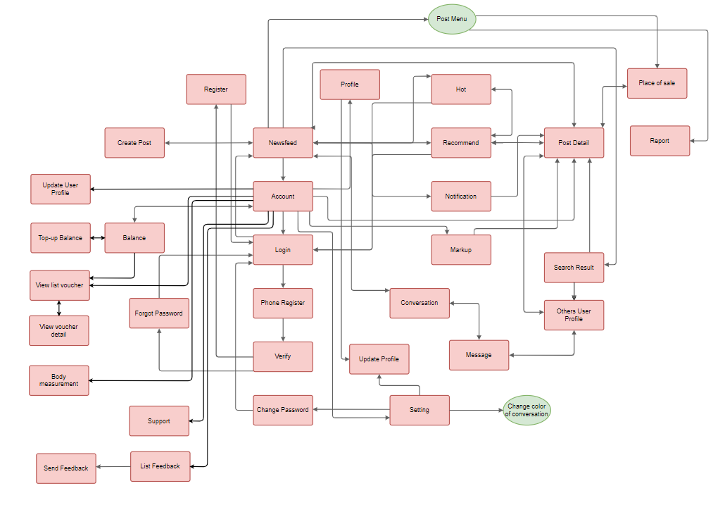

*Figure 3.3.1.1 – SOFA application screen flow*

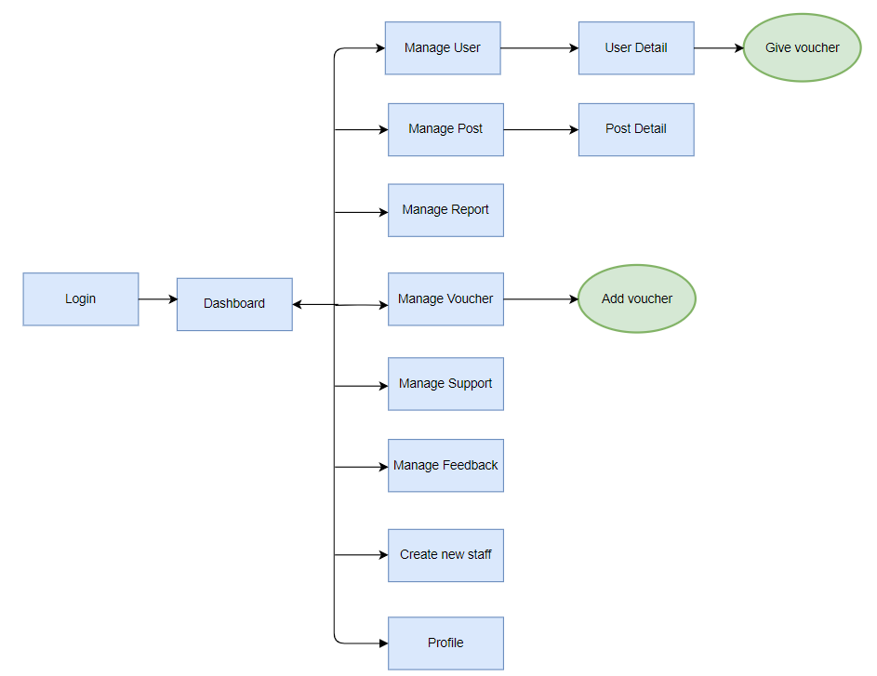

*Figure 3.3.1.2 – SOFA management screen flow*

b. Screen Details

|  |  |  |  |
| --- | --- | --- | --- |
| **#** | **Feature** | **Screen** | **Description** |
| 1 |  | Introduction | This screen use for introduce the application for user |
| 2 | View newsfeed | Newsfeed | This screen contain all posts which users have post |
| 3 | Logout, view my profile | User Profile | This screen use for view current user profile |
| 4 | Login | Login | This screen use for enter username and password the submit to the server for authentication |
| 5 | Register | Register | This screen allow guest can register their account |
| 6 | Forgot password, change password, verification | Verify | This screen use for get request send authentication code then check if it true it will forward to next step |
| 7 | Forgot password, change password | Change Password | This screen use for get password if user forgot their password or change password |
| 8 | Hot | Hot | This screen display all the post which have high react, rate or like, comment |
| 9 | Recommend | Recommend | This screen use for display the recommendation system |
| 10 | View list notification | Notification | This screen use to view list notification |
| 11 | Markup | Markup | This screen use to view all markup post |
| 12 | View post detail, like post, rate post, comment post, report post, markup, delete post | Post Detail | This screen use to view post detail |
| 13 | Show suggest place of sale | Place of Sale | This screen use to show place that sale the current item |
| 14 | Report | Report | This screen use for reporting |
| 15 | Search people, search post | Search Result | This screen use for searching people or post |
| 16 | Follow User, unfollow user, block user, report user, view other profile | Other User Profile | This screen use for view other user profile |
| 17 | Chat, delete conversation, view list conversation | Message | This screen use for viewing all of list conversation |
| 18 | Chat, delete message in conversation | Conversation | This screen use for chatting with other user |
| 19 | Create Post, Update Post | Create Post | This screen use for updating post, creating post |
| 20 | Update user profile | Update User Profile | This screen use for updating user profile |
| 21 | View balance, top-up account | Top-up Balance | This screen use for viewing balance and topping-up  balance |
| 22 | View list voucher | View list voucher | This screen use for viewing list voucher |
| 23 | View voucher detail | View voucher detail | This screen use for viewing voucher detail |

*Table 3.3.1.1 – Screen detail*

c. Screen Authorization

|  |  |  |  |
| --- | --- | --- | --- |
| **Screen** | **Guest** | **User** | **Manager** |
| Introduction | X | X |  |
| Newsfeed |  |  |  |
| * View newsfeed | X | X |  |
| Login | X |  |  |
| Register | X | X |  |
| Verify | X | X |  |
| Change Password |  | X |  |
| Forgot Password | X | X |  |
| Hot | X | X |  |
| Recommend |  | X |  |
| Notification |  | X |  |
| Mark-up |  | X |  |
| Post Detail |  |  |  |
| * View post detail | X |  |  |
| * Like post |  | X |  |
| * Rate post |  | X |  |
| * Comment |  | X |  |
| * Report |  | X |  |
| * Mark-up |  | X |  |
| * Delete |  | X |  |
| Place of Sale |  | X |  |
| Search Result |  | X |  |
| Other User profile |  | X |  |
| Message |  | X |  |
| Conversation |  | X |  |
| Create Post |  | X |  |
| Update User Profile |  | X |  |
| Balance |  | X |  |
| Top-up balance |  | X |  |
| View list voucher |  | X |  |
| View voucher detail |  | X |  |
| Manager Login |  |  | X |
| Dashboard |  |  | X |
| Create new Staff |  |  | X |
| Manage Post |  |  | X |
| Manage User |  |  | X |
| Manage User |  |  | X |
| Manage Report |  |  | X |
| Manage Voucher |  |  | X |
| Manage Users Balance |  |  | X |
| Manage Recommendation Data |  |  | X |
| Manager Profile |  |  | X |
| Post Detail |  |  | X |
| User Detail |  |  | X |
| Report Detail |  |  | X |

*Table 3.3.1.2 – Screen Authorization*

d. Non-Screen Functions

|  |  |  |  |
| --- | --- | --- | --- |
| **#** | **Feature** | **System Function** | **Description** |
| 1 | Web API | Web API | A web server or a web browser, knows as web development concept, usually limited to a web application's client-side, and thus usually does not include web server or browser implementation details. |
| 2 | Service | Architectural pattern | Applied within the service-orientation design paradigm, which aims to organize the services, within a service inventory, into a set of logical layers. Services that are categorized into a particular layer share functionality. |
| 3 | Image moderation | Clarifai API | Uses machine learning and deep neural networks to identify and analyze images. |
| 4 | Detect implicit content of image | Google Cloud's Vision API | Assign labels to images and quickly classify them into millions of predefined categories. Detect objects and faces, read printed and handwritten text, and build valuable metadata into your image catalog. |

*Table 3.3.1.3 – Non-Screen function*

e. Entity Relationship Diagram

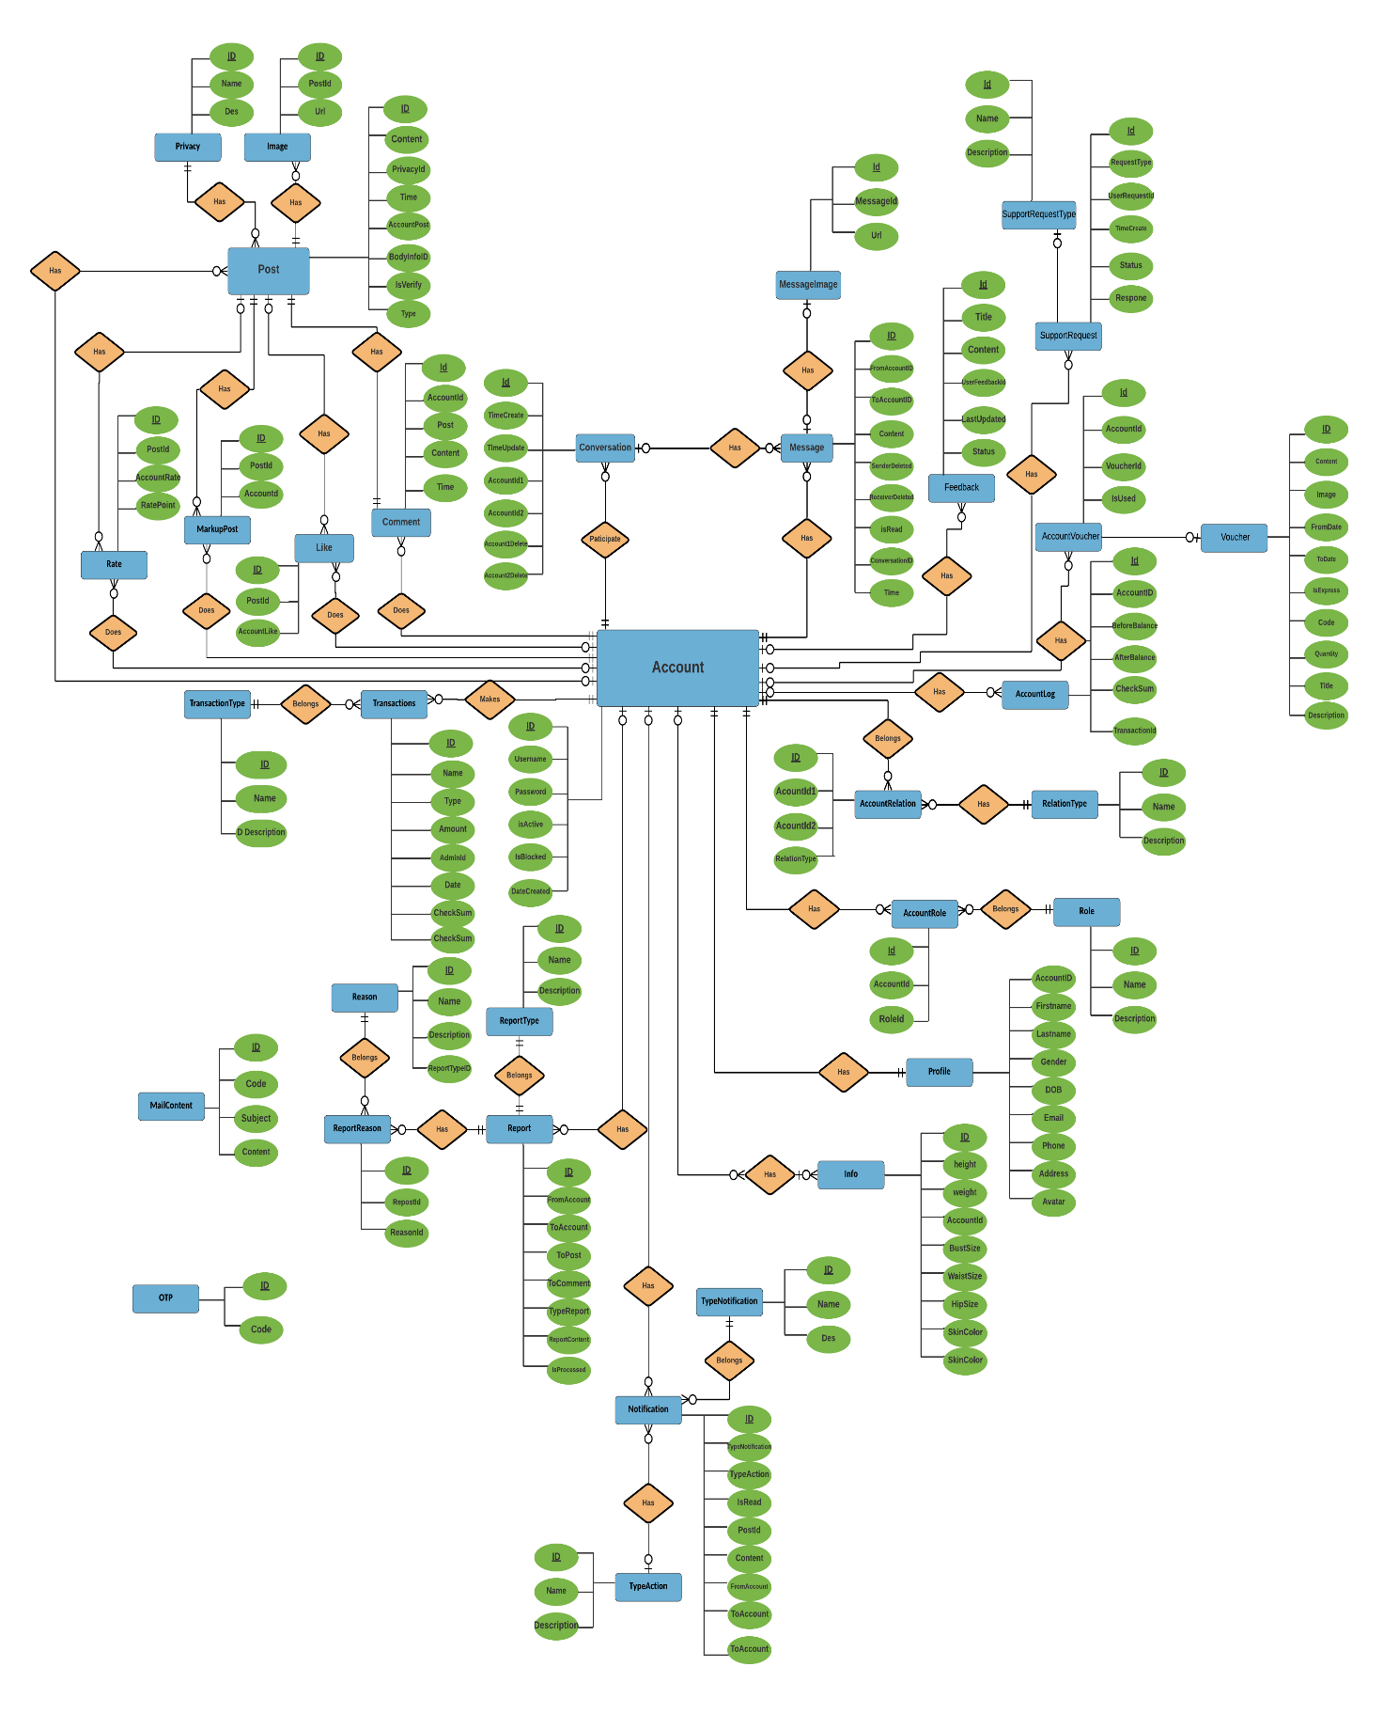

*Figure 3.3.1.3 – Usecase diagram*

3.2 Mockup Screen

1. **Mockup Screen Newsfeed**



1. **Mockup Screen Hot**



1. **Mockup Screen Recommendation**



1. **Mockup Screen Post Detail**



1. **Mockup Screen Place of Sale**



1. **Mockup Screen Create Post**



1. **Mockup Screen Login**



1. **Mockup Screen Register**



1. **Mockup Screen Verify**



1. **Mockup Screen Change Password**



1. **Mockup Screen Introduction**



1. **Mockup Screen Notification**



1. **Mockup Screen User Profile**



1. **Mockup Screen Update user profile**
2. **Mockup Screen Markup**



1. **Mockup Screen Message**



1. **Mockup Screen Conversation**
2. **Mockup Screen Other user**



1. **Mockup Screen Balance**



1. **Mockup Screen Top-up balance**



1. **Mockup Screen View list voucher**



1. **Mockup Screen View voucher detail**



1. **Mockup Screen Report**



1. **Mockup Screen Search result**



1. **Mockup Screen Manager - Login Page**



1. **Mockup Screen Manager – Dashboard**



1. **Mockup Screen Manager - Create new staff**



1. **Mockup Screen Manager - Manage Post**



1. **Mockup Screen Manager - Manage User**



1. **Mockup Screen Manager - Manage Report**



1. **Mockup Screen Manager - Manage Voucher**



1. **Mockup Screen Manager - Manage User Balance**



1. **Mockup Screen Manager - Manage Recommendation Data**



1. **Mockup Screen Manager – Profile**



1. **Mockup Screen Manager - User detail**



1. **Mockup Screen Manager - Post Detail**



## 4. Non-Functional Requirements

4.1 External Interfaces

a. User Interfaces

UI-1: The SOFA application on smartphone is used entirely by touch and swipe.

UI-2: The SOFA application always includes a status bar at the bottom of the page to navigate between the application's features.

UI-3: The Management System conforms to the Dashboard Design User Experience Guidelines.

UI-4: The Management System in browser permits complete navigation by using the mouse alone, in addition to using mouse and keyboard combinations.

b. Software Interfaces

SI-1: Detect implicit content of image (Google cloud vision AI)

SI-1.1: After the photo is uploaded from the user's phone through the SOFA app, it will be sent through the image censorship system, while waiting for the censorship, the photo is only viewed as a preview.

SI-1.2: Through Vision AI, the system will evaluate and make a decision about whether a photo is suitable or not.

SI-1.3: When a posted photo is determined to be invalid, it is immediately removed from the preview interface.

SI-2: Recommendation System

SI-2.1: The Recommendation System collects information from photos posted from users.

SI-2.2: After collecting information, based on information about the user's body, the system will give suggestions on suitable outfits to the user through the recommendation page.

SI-3: Purchase Management System

SI-3.1: To allow users to top up the system: using ZaloPay API

SI-3.2: To allows users to pay for advertising posts page.

SI-4: Virtual Search System (Google cloud vision AI)

SI-4.1: Through Google Cloud Vision AI, the system will allow users to find similar clothes by image

c. Hardware Interfaces

No hardware interfaces have been identified.

d. Communications Interfaces

CI-01: The system sends an email to the user to confirm transactions (top up, advertise) in the system.

CI-02: The system will send the OTP code to the phone number signed by the user to authenticate the action (top up, advertise, change information).

CI-03: In addition to the usual login, users can choose to log in with a Google or Facebook account.

4.2 Quality Attributes

a. Usability

* The application has a stylish, vintage interface with the ocean blue main color
* The system has a friendly and good-looking GUI which makes it easy for users of all ages to access, helps users feel comfortable when using the application.
* The interface of main functions is learned, inherited, and developed from previous successful systems such as Facebook, Instagram, ... This gives users a sense of familiarity when using the software and helps users access the functions of the system more effectively.

b. Reliability

* The system complies with business rules.
* The application is guaranteed to run smoothly, without errors, stable and safe.
* The display of personal information such as email, phone number, measurements, ... will be private

c. Performance

* Two functions (Message and Notification) are real-time updates. When a new message or notification appears, users will receive it immediately
* The system allows 10000 users at a time

d. Security

* Each email, phone number is only validated for one account. Users can use a Google account to log in as long as it has the same email as the one used to authenticate the account.
* The system must use HTTPS to encrypt the information transferred between clients and servers.
* Use the JWT Bearer Token to authenticate users
* Before uploading a file to the system, the file will be verified for the correct file format which helps reduce the likelihood of being hacked with a web shell
* The user authorization table is as follow:

|  |  |  |  |  |
| --- | --- | --- | --- | --- |
| **Function** | | **Super Admin** | **Staff** | **Users** |
| Login | | ✔ | ✔ | ✔ |
| Logout | | ✔ | ✔ | ✔ |
| Manage staffs | | ✔ |  |  |
| Manage accounts | | ✔ | ✔ |  |
| Manage posts | Report posts |  |  | ✔ |
| Ban posts | ✔ | ✔ |  |
| Other managements |  |  | ✔ |
| Manage users | | ✔ | ✔ |  |
| Manage notifications | |  |  | ✔ |
| Manage messages | |  |  | ✔ |
| Manage vouchers | | ✔ | ✔ |  |
| Manage configure email | | ✔ |  |  |
| Manage to reach posts | |  | ✔ | ✔ |
| Manage data of recommendation system | | ✔ |  |  |

e. Maintainability

This system uses RESTFUL API structure with ASP.NET Core, with the following advantages to maintain:

* We can easily maintain our application because of the separation of concern.
* At the same time, we can split many developers' work at a time. It will not affect one developer's work to another developer's work.

f. Portability

The system is created by using API and React Native which can be developed in the future to supports responsiveness for all screens: mobiles, desktops, tablets, laptops (For candidate view)

## 5. Other Requirements

5.1 Appendix1 - Messages List

|  |  |  |  |  |
| --- | --- | --- | --- | --- |
| **#** | **Message code** | **Message Type** | **Context** | **Content** |
| 1 | MSG01 | In line | There is not any search result | *No search result.* |
| 2 | MSG02 | In red, under the text box | Input-required fields are empty | *The * field is required.* |
| 3 | MSG03 | Toast message | Updating information successfully | *Update profile successfully.* |
| 4 | MSG04 | Toast message | Login successfully | *Login successfully.* |
| 5 | MSG05 | Toast message | Change password successfully | *Change password successfully.* |
| 6 | MSG06 | Toast message | Confirming email sent successfully | *A confirmation email has been sent to {email_address}.* |
| 7 | MSG07 | In line | Account has been blocked | *Account has been blocked, please check email or contact admin* |
| 8 | MSG08 | In line | Account or password incorrect | *Account or password incorrect please try again* |
| 9 | MSG09 | In red, under the text box | Input value length > max length | *Exceed max length of {max_length}.* |
| 10 | MSG10 | In line | Username or password is not correct when clicking sign-in | *Incorrrect user name or password. Please check again.* |
| 11 | MSG11 | In red, under the text box | Email not valid | *Please enter valid email* |

*Table 3.5.1.1 – Appendix1 – Messages list*

5.2 Appendix2 - API List

1. ***Clarifai***



*Figure 3.5.2.1 – Appendix2 – Clarifai API*

**Clarifai** is an Image Recognition Software solution highly appreciated by both users and experts in the field of Deep Learning Software.

The platform includes the ability to moderate content, perform visual search, visual similarity, and organize media collections. It has pre-built recognition models that can identify a specific set of concepts like food or travel, NSFW, and its general model which can identify a range of concepts including objects, ideas, and emotion. It also has the ability to create custom models which can identify other arbitrary objects such as cars or breeds of dogs.

1. ***Zalopay***



*Figure 3.5.2.2 – Appendix2 – Zalopay API*

Zalo Pay is an e-wallet platform and online payment system developed by VNG to deploy in-app payments and scan QR codes for payment on mobile devices, allowing users to do so. transactions using phones and tablets running Android and iOS. For many years (from 2018 to 2020), many channels have been introduced as the top 5 recommended e-wallets in Vietnam

**Chapter 4: Detailed Description of Components**

## *System Architecture Design*

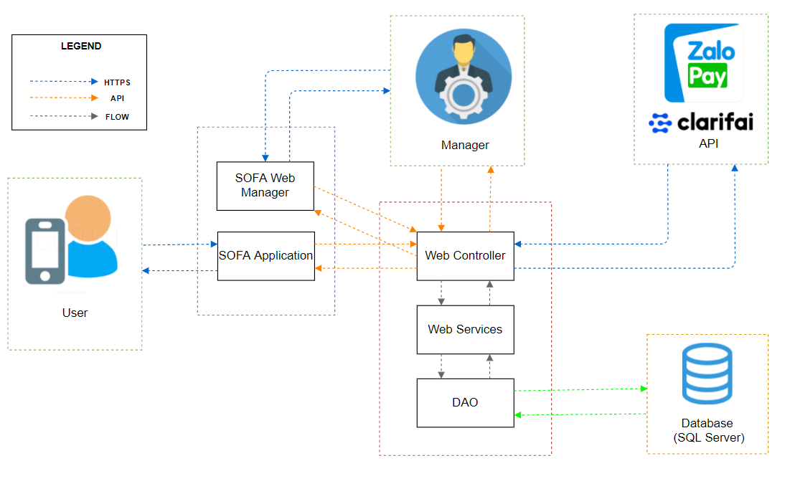

*Figure 4.1.1 – System Architecture Design*

## *Software Architecture Design*

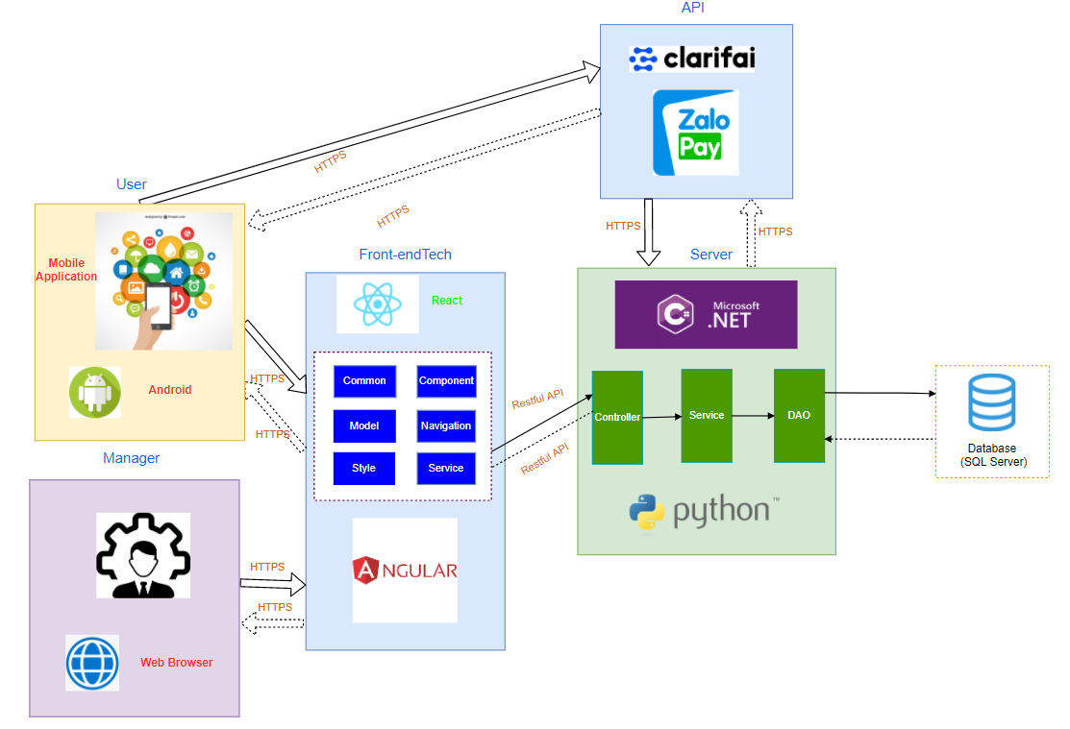

*Figure 4.2.1 – Software Architecture Design*

## *3. Description of System Interface*

***3. 1. Database management system***

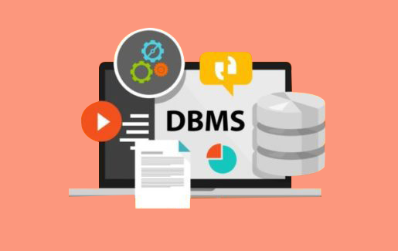

*Figure 4.3.1.1 - Database management system*

Database management system is a software which is used to manage the database. For example: SQL Server, MySQL, Oracle, etc. are a very popular commercial database which is used in different applications. DBMS provides an interface to perform various operations like database creation, storing data in it, updating data, creating a table in the database and a lot more. It provides protection and security to the database. In the case of multiple users, it also maintains data consistency.

***3.2. Clarifai***



*Figure 4.3.2.1 – Clarifai API*

**Clarifai** is an Image Recognition Software solution highly appreciated by both users and experts in the field of Deep Learning Software.

The platform includes the ability to moderate content, perform visual search, visual similarity, and organize media collections. It has pre-built recognition models that can identify a specific set of concepts like food or travel, NSFW, and its general model which can identify a range of concepts including objects, ideas, and emotion. It also has the ability to create custom models which can identify other arbitrary objects such as cars or breeds of dogs.

***3.3. Zalopay***



*Figure 4.3.3.1 – Clarifai API*

Zalo Pay is an e-wallet platform and online payment system developed by VNG to deploy in-app payments and scan QR codes for payment on mobile devices, allowing users to do so. transactions using phones and tablets running Android and iOS. For many years (from 2018 to 2020), many channels have been introduced as the top 5 recommended e-wallets in Vietnam

## 4. Component Diagram



*Figure 4.4.1 – Component diagram*

## 5. Detailed Description of Component

***5.1. View***



*Figure 4.5.1.1 – Detailed description component - View*

## Class Diagram

***6.1. Class diagram***

***6.1.1. Post Class Diagram***



*Figure 4.6.1.1 – Post Class Diagram*

***6.1.2. Account Class Diagram***



*Figure 4.6.1.2 – Account Class Diagram*

***6.1.3. Profile Class Diagram***



*Figure 4.6.1.3 – Profile Class Diagram*

***6.1.4. Notification Class Diagram***



*Figure 4.6.1.4 – Notification Class Diagram*

***6.1.5. Message Class Diagram***



*Figure 4.6.1.5 – Message Class Diagram*

***6.2. Models***

***6.2.1 Account***



*Figure 4.6.2.1 – Account model*

**Class specification**

|  |  |  |  |
| --- | --- | --- | --- |
| **NO** | **Attribute** | **Type** | **Description** |
| 01 | id | int | ID of account |
| 02 | username | string | User Name of account |
| 03 | password | string | Password of account |
| 04 | isActive | boolean | Status active of account |
| 05 | isBlock | boolean | Status block of account |

|  |  |  |
| --- | --- | --- |
| **NO** | **Method** | **Description** |
| 01 | Account(int iD, string userName, string password, bool isActive, bool isBlock) | Default constructor |
| 02 | Account(DataRow row) | Another constructor |

***6.2.2 AccountLog***



*Figure 4.6.2.2 – AccountLog model*

**Class specification**

|  |  |  |  |
| --- | --- | --- | --- |
| **NO** | **Attribute** | **Type** | **Description** |
| 01 | id | int | ID of log |
| 02 | accountID | int | ID of account log |
| 03 | beforeBalance | double | Balance of account before transaction |
| 04 | afterBalance | double | Balance of account after transaction |
| 05 | transactionID | int | ID of transacation |

|  |  |  |
| --- | --- | --- |
| **NO** | **Method** | **Description** |
| 01 | AccountLog(int iD, int accountID, double beforeBalance, double afterBalance, int transactionID) | Default constructor |
| 02 | AccountLog(DataRow row) | Another constructor |

***6.2.3 Comment***



*Figure 4.6.2.3 – Comment model*

**Class specification**

|  |  |  |  |
| --- | --- | --- | --- |
| **NO** | **Attribute** | **Type** | **Description** |
| 01 | id | int | Id of comment |
| 02 | accountID | int | Id of account comment |
| 03 | postID | int | Id of the post |
| 04 | content | string | Content of the comment |
| 05 | time | DateTime | Time comment is created |

|  |  |  |
| --- | --- | --- |
| **NO** | **Method** | **Description** |
| 01 | Comment(int id, int accountID, int postID, string content, Datetime time) | Default constructor |
| 02 | Comment(DataRow row) | Another constructor |

***6.2.4 Feedback***



*Figure 4.6.2.4 – Feedback model*

**Class specification**

|  |  |  |  |
| --- | --- | --- | --- |
| **NO** | **Attribute** | **Type** | **Description** |
| 01 | id | int | Id of the feedback |
| 02 | title | string | Title of the feedback |
| 03 | content | string | Content of the feedback |
| 04 | userFeedbackId | id | Id of the user have send feedback |
| 05 | lastUpdated | string | The final date update the feedback |
| 06 | status | int | Status of Feedback:   * Status = 1: Resolved * Status = 2: Unresolved * Status = 3: Rejected |

|  |  |  |
| --- | --- | --- |
| **NO** | **Method** | **Description** |
| 01 | Feedback(int id,string title, string content, int userFeedbackId, string lastUpdated, int status) | Default constructor |
| 02 | Feedback(DataRow row) | Another constructor |

***6.2.5 Follow***



*Figure 4.6.2.5 – Follow model*

**Class specification**

|  |  |  |  |
| --- | --- | --- | --- |
| **NO** | **Attribute** | **Type** | **Description** |
| 01 | relationId | int | Relation of the Following :   * Relation = 1 : Follow * Relation = 2 : Block |
| 02 | followerId | int | Id of the user follow |
| 03 | userGetFollowId | int | Id of the user is followed |

|  |  |  |
| --- | --- | --- |
| **NO** | **Method** | **Description** |
| 01 | Follow() | Default constructor |
| 02 | Follow(int relationId, int followerId, int userGetFollowId) | Another constructor |

***6.2.6 Image***



*Figure 4.6.2.6 – Image model*

**Class specification**

|  |  |  |  |
| --- | --- | --- | --- |
| **NO** | **Attribute** | **Type** | **Description** |
| 01 | id | int | Id of the image |
| 02 | postId | int | Id of the post contain the image |
| 03 | url | string | The path to the image file |

|  |  |  |
| --- | --- | --- |
| **NO** | **Method** | **Description** |
| 01 | Image(int postID, string url) | Default constructor |
| 02 | Image(DataRow row) | Another constructor |

***6.2.7 Infor***



*Figure 4.6.2.7 – Info model*

**Class specification**

|  |  |  |  |
| --- | --- | --- | --- |
| **NO** | **Attribute** | **Type** | **Description** |
| 01 | id | int | Id of the Infor |
| 02 | accountID | int | Id of the account have the infor |
| 03 | height | double | Height of the person |
| 04 | weight | double | Weight of the person |
| 05 | bustSize | double | The size of the butt |
| 06 | waistSize | double | The size of the waist |
| 07 | hipSize | double | Size of the hip |
| 08 | name | string | Name of the Infor |

***6.2.8 Message***



*Figure 4.6.2.8 – Message model*

**Class specification**

|  |  |  |  |
| --- | --- | --- | --- |
| **NO** | **Attribute** | **Type** | **Description** |
| 01 | id | int | Id of the message |
| 02 | fromAccountId | int | Id of sender |
| 03 | toAccountId | int | Id of the receiver |
| 04 | content | string | Content of the message |
| 05 | senderDeleted | boolean | Status of the message on sender :   * Status = 0 : UnDeleted * Status = 1 : Deleted |
| 06 | receiverDeleted | boolean | Status of the message on receiver:   * Status = 0 : Undeleted * Status = 1 : Deleted |
| 07 | isRead | boolean | Status of the message on receiver is read:   * Relation = 0 : Unread * Relation = 1 : Read |
| 08 | conversationId | int | Id of the conversation |
| 09 | time | DateTime | Time of the message |

|  |  |  |
| --- | --- | --- |
| **NO** | **Method** | **Description** |
| 01 | Message(int iD, int fromAccountId, int toAccountId, string content,boolean senderDeleted, boolean receiverDeleted, boolean isRead,int conversationId, DateTime, time) | Default constructor |
| 02 | Message(DataRow row) | Another constructor |

**6.3. DAO**

***6.3.1 AccountDAO***



*Figure 4.6.3.1 – AccountDAO*

**Class specification**

|  |  |  |
| --- | --- | --- |
| **NO** | **Method** | **Description** |
| 01 | AddAccount(AccountViewModelIn accountViewModel) | Create an account for users |
| 02 | AddNewStaff(AccountViewModelIn) | Create a new account for staff manager |
| 03 | GetUserWithRoleByUserName(string username) | Get information of users with their username |
| 04 | GetUserWithRoleByEmail(string username) | Get information of users with their Email |
| 05 | GetUserWithRoleByPhone(string username) | Get information of users with their Phone |
| 06 | UpdateUserPassword(string username, string newPassword) | Change user password |
| 07 | GetAllUser() | Get all user in system |
| 08 | GetUserById(int id) | Get an user’s account and profile by his/her ID |
| 09 | GetUserDetailById(int id) | Get an user’s profile and statistics |
| 10 | BanUser(int accountId) | Ban an user |
| 11 | UnbanUser(int accountId) | Unban an user |

***6.3.2. ProfileDAO***



*Figure 4.6.3.2 – ProfileDAO*

**Class specification**

|  |  |  |
| --- | --- | --- |
| **NO** | **Method** | **Description** |
| 01 | GetProfileModelByAccountID (int accountId) | Get an custom profile by account id |
| 02 | UpdateProfileByAccountID(int accountId, ProfileViewModelIn newProfile) | Update an profile by account id |
| 03 | UpdateAvatarByAccountID(int accountId, ProfileViewModelIn newProfile) | Update an user’s profile avatar by account id |
| 04 | GetProfileByAccountID(int id) | Get user’s profile by account id |
| 05 | GetProfileByEmail(string email) | Get user’s profile by user’s email |
| 06 | GetProfileByPhone(string phone) | Get user’s profile by user’s phone |
| 07 | getPeopleFollowByAccountId(int accountId) | Get people follow an account by account id |

***6.3.3 PostDAO***



*Figure 4.6.3.3 – PostDAO*

**Class specification**

|  |  |  |
| --- | --- | --- |
| **NO** | **Method** | **Description** |
| 01 | GetAllPost(int page, int rowsOfPage) | Get all public post in the system |
| 02 | GetAllPostByInfoID(int infoID, int page, int rowsOfPage) | Get all public post have body measurement equal infor id |
| 03 | CreatePost(Post post) | Create an post |
| 04 | GetPostByID(int id) | Get an post by its id |
| 05 | GetFashionistaPost(int page, int rowsOfPage) | Get fashionista’s post |
| 06 | GetAllPublicPostOfUser(int accountID, int page, int rowsOfPage) | Get all public post of user in the system |
| 07 | DeletePostByPostID(int postID) | Delete a post by its id |
| 08 | UpdatePost(int id, string content, int privacyID, DateTime time, int bodyInfoID, bool isVerified) | Update a post |
| 09 | SearchPostByText(string keyWord, int page, int rowsOfPage) | Search a post by keyword |
| 10 | CountPostOfUser(int accountID) | Get number of an user’s post |

***6.3.4 MessageDAO***



*Figure 4.6.3.4 – MessageDAO*

**Class specification**

|  |  |  |
| --- | --- | --- |
| **NO** | **Method** | **Description** |
| 01 | GetMessageByConversationId(int cid) | Get messages by conversation id |
| 02 | GetMessageBySenderAndReceiverId(int uid1, int uid2, int page, int rowsOfPage) | Get messages by sender and receiver |
| 03 | SetDeleteFlagForMessage(int messageId, bool isSenderDelete) | Delete an message in an conversation |
| 04 | createNewMessage(MessageViewModelIn mess) | Create a new message then create an conversation if it not belong into an existed conversation |

***6.3.5 NotificationDAO***



*Figure 4.6.3.2 – NotificationDAO*

**Class specification**

|  |  |  |
| --- | --- | --- |
| **NO** | **Method** | **Description** |
| 01 | GetNotificationByToAccount(int accountID, int page, int rowOfPage) | Get messages by conversation id |
| 02 | SetReadNotificationById(int ID) | Get messages by sender and receiver |
| 03 | CreateNotification(NotificationViewModelIn modelIn) | Delete an message in an conversation |
| 04 | AddNewNotificationFeedback(NotificationViewModelIn modelIn) | Create a new message then create an conversation if it not belong into an existed conversation |
| 05 | MarkAllAsRead(int accountID) |  |

**6.4 Controller**

***6.4.1 AuthController***



*Figure 4.6.4.1 – AuthController*

**Class specification**

|  |  |  |
| --- | --- | --- |
| **NO** | **Method** | **Description** |
| 01 | Register([FromForm] AccountViewModelIn data) | Register for an account |
| 02 | Login([FromForm] AccountViewModelIn data) | Login for an user to the system |
| 03 | ResetPassword([FromForm] AccountViewModelIn data) | Reset password for an user |
| 04 | AddNewStaff([FromForm] AccountViewModelIn data) | Add new staff for admin web server |
| 05 | AdminResetPassword([FromForm] int accountId) | Reset password for admin |

*6.4.2 InfoController*



*Figure 4.6.4.2 – InfoController*

**Class specification**

|  |  |  |
| --- | --- | --- |
| **NO** | **Method** | **Description** |
| 01 | GetAllInfo() | Get all body measurement of all users |
| 02 | GetUserInfo() | Get body measurement of an user |
| 03 | CreateInfo([FromForm] InfoViewModelIn infoViewModelIn) | Create an body measurement for an user |
| 4 | Delete(int infoID) | Delete an body measurement of an user |

*6.4.3 ProfileController*



*Figure 4.6.4.3 – ProfileController*

**Class specification**

|  |  |  |
| --- | --- | --- |
| **NO** | **Method** | **Description** |
| 01 | GetProfile() | Get user’s profile |
| 02 | GetOtherProfile(int id) | Get another user’s profile |
| 03 | UpdateProfile([FromForm] ProfileViewModelIn newProfile) | Update user’s profile |
| 04 | UpdateAvatar([FromForm] ProfileViewModelIn newProfile) | Update user’s avatar |
| 05 | GetFollower(int accountId) | Get follower of user |
| 06 | SearchUserByName(string keyword, int page, int rowsOfPage) | Search user by name |

*6.4.4 PostController*



*Figure 4.6.4.4 – PostController*

**Class specification**

|  |  |  |
| --- | --- | --- |
| NO | Method | Description |
| 01 | GetAllPost(int page, int rowsOfPage) | Get all users’s posts |
| 02 | GetFashionistaPost(int page, int rowsOfPage) | Get fashionistas’s posts |
| 03 | GetUserPublicPost(int accountPost, int page, int rowsOfPage) | Get public user’s posts |
| 05 | LikePost([FromForm] PostViewModelIn postViewModelIn) | Like a post |
| 06 | UnLikePost([FromForm] PostViewModelIn postViewModelIn) | Unlike a post |
| 07 | RatePost([FromForm] PostViewModelIn postViewModelIn) | Rate a post |
| 08 | CommentPost([FromForm] PostViewModelIn postViewModelIn) | Comment a post |
| 09 | CreatePost([FromForm] PostViewModelIn postViewModelIn) | Create a new post |
| 10 | GetPostDetail(int postID, int commentRowsOfPage) | Get detail of a post |
| 11 | UpdatePostContent([FromForm] PostViewModelIn postViewModelIn) | Update a post’s content |
| 12 | SearchPostByImage([FromForm] PostViewModelIn postViewModelIn) | Search a post by Image |
| 13 | SearchPostByText(string keyword, int page, int rowsOfPage) | Search a post by keyword |

*6.4.5 NotificationController*



*Figure 4.6.4.5 – NotificationController*

**Class specification**

|  |  |  |
| --- | --- | --- |
| **NO** | **Method** | **Description** |
| 01 | GetNotificationByUserID(int page, int rowsOfPage) | Get notification of user |
| 02 | SetReadNotificationById(int ID) | Set a notification is read |
| 03 | MarkAllAsRead() | Set all notifications are read |

*6.4.6 MessageController*



*Figure 4.6.4.5 – MessageController*

**Class specification**

|  |  |  |
| --- | --- | --- |
| **NO** | **Method** | **Description** |
| 01 | GetMessageInConversation(int cid) | Get messages in a conversation |
| 02 | GetMessageByDirectTwoId(int uid2, int page, int rowsOfPage) | Get messages by user |
| 03 | CreateNewMessage([FromForm] MessageViewModelIn newMessage) | Send a message to another user |
| 04 | DeleteMessage(int messageId, bool isSenderDelete) | Delete a message |

*6.4.7 ConversationController*



*Figure 4.6.4.7 – ConversationController*

**Class specification**

|  |  |  |
| --- | --- | --- |
| **NO** | **Method** | **Description** |
| 01 | GetListConversation() | Get list user’s conversation |
| 02 | SearchConversation([FromForm] SearchCoversationViewModelIn modelIn) | Search conversation by username |
|  | DeleteMessage([FromForm] ConversationViewModelIn modelIn) | Delete a conversation |
|  | MarkMessageIsReaded(int messageID) | Mark conversation is read |

## 7. Sequence Diagram

***7.1. Create New Post***



*Figure 4.7.1 – Create new post sequence diagram*

***7.2. View post detail***



*Figure 4.7.2 – View post detail sequence diagram*

***7.3. Update post***

***\***

*Figure 4.7.3 – Update post sequence diagram*

***7.4. Update Profile***



*Figure 4.7.4 – Update post sequence diagram*

***7.5. Chat***

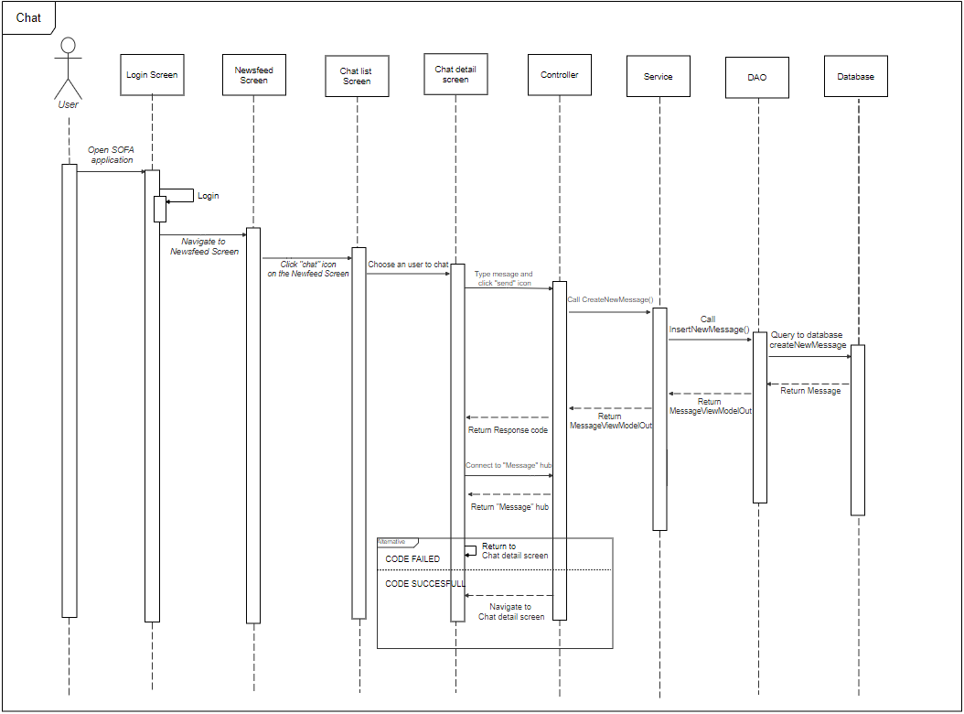

*Figure 4.7.5 – Chat sequence diagram*

***7.6. Like Post***



*Figure 4.7.6 – Like post sequence diagram*

## User Interface Design

*8.1. Screen Image*

8.1.1 Login



8.1.2. Register



8.1.3. Newsfeed



8.1.4 Hot

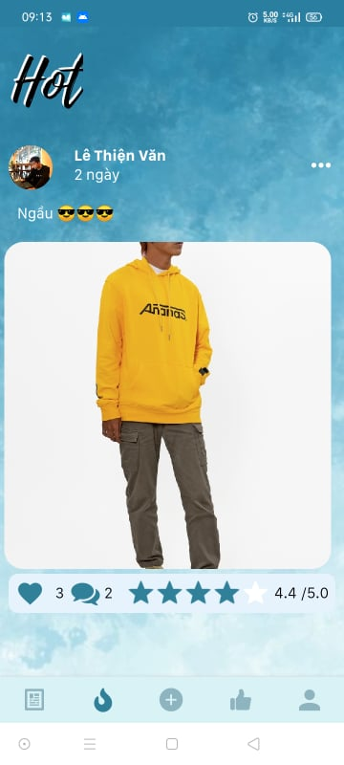

8.1.5 Recommend



8.1.6 Create Post



8.1.7. Post Detail



8.1.8 Search



8.1.9 Notification

8.1.10 Chat



8.1.11 Bookmark



8.1.12 Account



8.1.13 Profile



8.1.14 Edit Profile



8.1.15 Balance



## Database Design

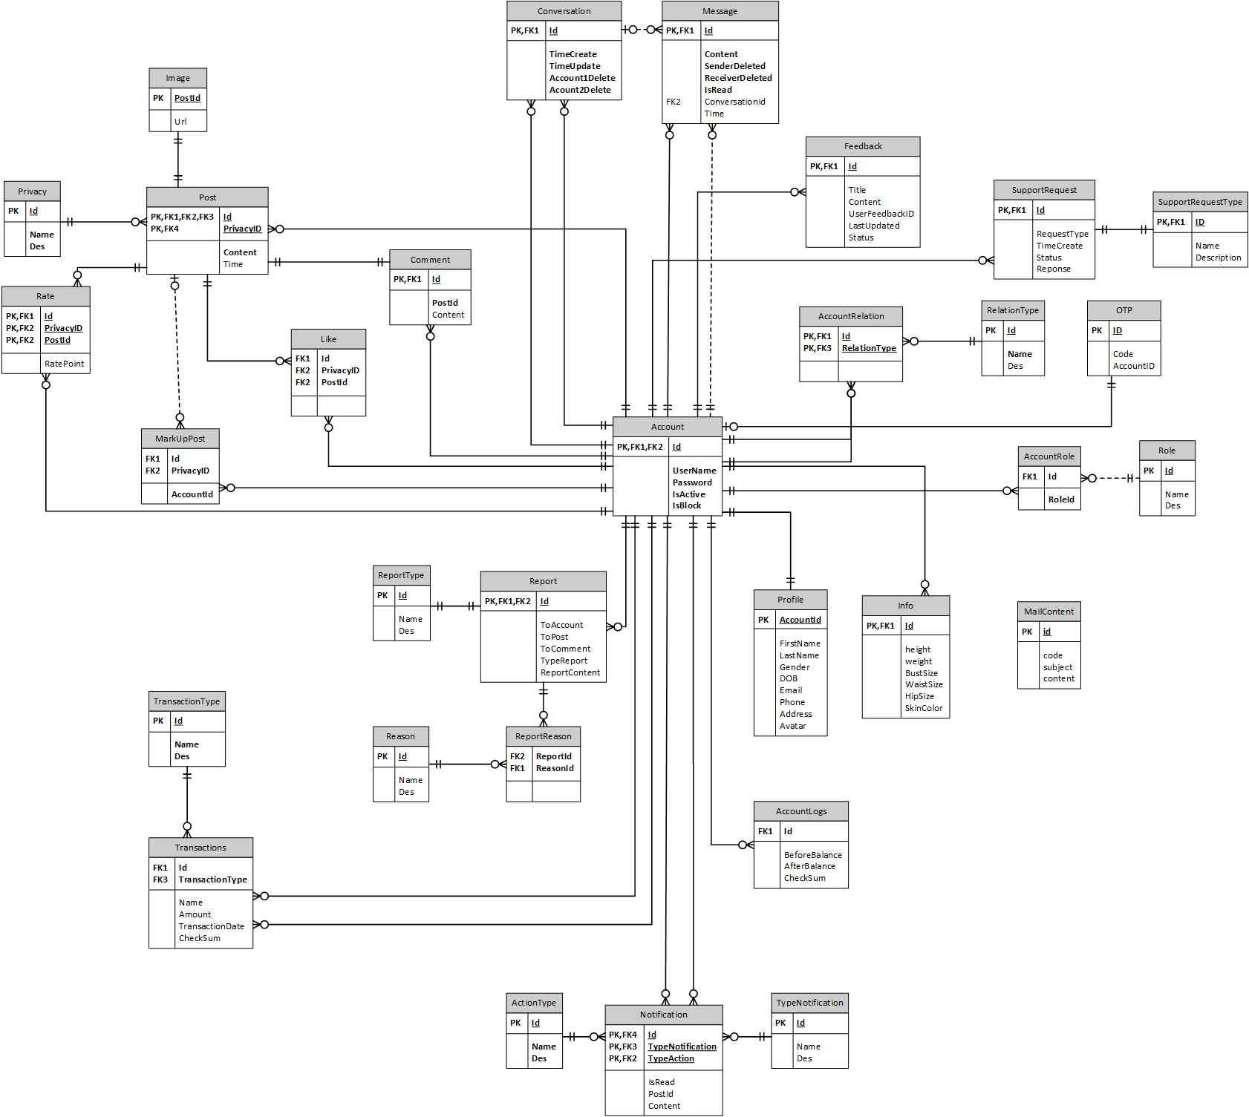

*Figure 4.9.1 – Database Design*

# Chapter 5: Software Test Documentation

## Purpose

The primary purpose of this chapter is to detect and prevent defects which may be created by developers while developing the software and this may lead to software failures. On the other hand, another objective of this chapter is to provide information about the level of quality and to make sure that the end result meets the business and user requirements. It contains the following sections:

* Test approach
* Test stages
* Test type
* Test plan: Feature to be tested, Feature not to be tested, Test process, Test schedule, Testing tool and environment.
* Test cases
* Checklist
* Test report

1. **Test Approach**

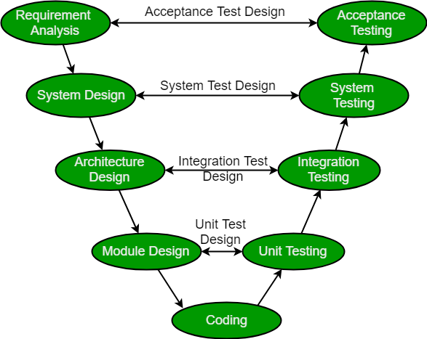

*Figure 5.2.1 – Test Approach*

Overall, we choose V-Model to implement the testing process. With V-Model, software development is separated into two appropriate phase’s groups: development and testing. In this model, the verification and validation will be done side by side. It emphasizes the strict process flow to develop a quality product. The errors occurring in any phase will be corrected in that phase. Proactive defect tracking defects, which are found at early stages even, may be in the development phase before application being tested.

1. **Testing Types**

The test team has to test the following type on SOFA Application and Google Chrome:

* GUI test
* Function test
* Acceptance test
* Unit test

|  |  |  |  |
| --- | --- | --- | --- |
| **Type of test** | **Stage of test** | | |
| **Integration test** | **System test** | **Acceptance test** |
| Unit test | x | x |  |
| GUI test |  | x | x |
| Function test | x | x | x |
| Acceptance test |  | x | x |

*Table 5.3.1 – Testing type*

## Test Plan

4.1 Test Stages

In this project, there are 3 phases in the testing process: Integration testing, System testing and Acceptance testing.

|  |  |  |
| --- | --- | --- |
| No. | Test Stages | Description |
| 1 | Integration testing | Integration testing allows individuals the opportunity to combine all of the units within a program and test them as a group. This testing level is designed to find interface defects between the modules/functions. This is particularly beneficial because it determines how efficiently the units are running together. |
| 2 | System testing | System testing is the first level in which the complete application is tested as a whole. The goal at this level is to evaluate whether the system has complied with all of the outlined requirements and to see that it meets Quality Standards. |
| 3 | Acceptance testing | Acceptance testing (or User Acceptance Testing), is conducted to determine whether the system is ready for release. During this phase, the tester and some alpha test users will test the system to find out whether the application meets their business’ needs. |

*Table 5.4.1.1 – Testing type*

4.2 Resources

a. Human Resources

|  |  |  |
| --- | --- | --- |
| **Worker/Doer** | **Role** | **Specific Responsibilities/Comments** |
| VienMV | Test lead | Make a Test plan, Create test reports |
| VanLT | Member | Unit test |
| TungNT | Member | Unit test |
| DungHV | Member | System test |
| HoangNH | Member | GUI test, System test |

*Table 5.4.2.1 – Human Resource*

b. Environment

* Chrome 84.0.4147.135 (64-bit) DevTools: To view logs, inspect elements, lighthouse.

*Figure 5.4.2.1 - Chrome dev tools*

* Google sheet: To manage test documents

*Figure 5.4.2.2 - Google sheet*

* Microsoft Visual Studio 17: To run unit tests and create/ update code unit tests.

*Figure 5.4.2.3 - Microsoft visual*

* Apache JMeter 5.4.1: To test performance



*Figure 5.4.2.4 - Jmeter*

* Trello: To log bug and manager task

**

*Figure 5.4.2.5 - Trello*

|  |  |  |
| --- | --- | --- |
| **Type of testing** | **Software** | **Hardware** |
| System test & Acceptance test & Test case | * Google Sheet. * Google Docs. * Google Chrome 84.0.4147.135 (64-bit) | Personal computer for developing with the minimum configuration:  - Laptop Asus  - 2.20GHz Intel Core i7  - RAM: 16GB  Personal mobile phone for run testing with configuration:   * Samsung galaxy note 10 * Os: android 9.0 (pie) * Chip: Exynos 9825 * Ram: 8GB |
| Unit test | * Microsoft Visual Studio 2017 | Personal computer for run testing with minimum configuration:   * Laptop Asus rog gl552vx * Core i7 6700HQ 2.6GHz * RAM: 8GB |
| Performance Test | * Apache Jmeter 5.4.1 | Personal computer for run testing with minimum configuration:   * Laptop Asus rog gl552vx * Core i7 6700HQ 2.6GHz * RAM: 8GB |

*Table 5.4.2.5 – Testing Environment*

4.3 Features to be tested

|  |  |  |
| --- | --- | --- |
| **ID** | **Use Case** | **Actors** |
| 01 | View newsfeed | Guest |
| 02 | Register | Guest |
| 03 | Login | Guest |
| 04 | Forgot password | User |
| 05 | Verification | User |
| 06 | Logout | User |
| 07 | View newsfeed | User |
| 08 | View post detail | User |
| 09 | Like post | User |
| 10 | Rate post | User |
| 11 | Comment post | User |
| 12 | Report post | User |
| 13 | Markup | User |
| 14 | Post a post | User |
| 15 | Update post | User |
| 16 | Delete post | User |
| 17 | Follow users | User |
| 18 | Unfollow users | User |
| 19 | Block users | User |
| 20 | Report users | User |
| 21 | View other user’s profile | User |
| 22 | Chat | User |
| 23 | Delete message in the conversation | User |
| 24 | Delete conversation | User |
| 25 | View list conversation | User |
| 26 | Search a conversation | User |
| 27 | View my profile | User |
| 28 | Update my profile | User |
| 29 | Search people | User |
| 30 | Search post | User |
| 31 | View list notification | User |
| 32 | View a notification | User |
| 33 | View hot posts | User |
| 34 | Recommend | User |
| 35 | Show suggest place of sale | User |
| 36 | View balance | User |
| 37 | Top up account | User |
| 38 | View list voucher | User |
| 39 | View voucher detail | User |
| 40 | Login | Manager |
| 41 | Logout | Manager |
| 42 | Create new staff | Manager |
| 43 | View list user | Manager |
| 44 | Search user | Manager |
| 45 | Ban user | Manager |
| 46 | Reset password for user | Manager |
| 47 | View list post | Manager |
| 48 | View post detail | Manager |
| 49 | Search user’s post | Manager |
| 50 | Delete post | Manager |
| 51 | Manage voucher | Manager |
| 52 | View list report | Manager |
| 53 | View report detail | Manager |
| 54 | Manage recommend data | Manager |
| 55 | Manage user’s balance | Manager |
| 56 | Manage my profile | Manager |

*Table 5.4.3.1 – Fearture to be tested*

4.4 Test process



*Figure 5.4.4.1 – Test process*

* Test Planning and Control use requirement specification test plans will make more detailed decisions about the overall approach of testing.
* Test Analysis and Design design and create test cases.
* Test Implementation and Execution: execute test procedures using test execution tools, check actual results with expected results.
* Evaluating exit criteria and Reporting defines when to stop testing based on time.
* Test closure activities update Test Report and if there is an error then report error.

4.5 Test schedule

The table below describes the test schedule for the SoFa Project:

|  |  |  |  |
| --- | --- | --- | --- |
| **Test Schedule** | **Start Date** | **End Date** | **Responsibilities** |
| Unit test | April 04, 2021 | April 18, 2021 | TungNT, VanLT |
| GUI test | March 18, 2020 | March 22, 2020 | VienMV, HoangNH |
| System test | March 18, 2020 | April 29, 2021 | VienMV, HoangNH, DungHV |
| Acceptance test | April 18, 2021 | April 26, 2021 | User |

*Table 5.4.5.1 – Test schedule*

## Test Cases

Test cases have been managed on the [Test Case Sheet](https://drive.google.com/file/d/1X_9vBe1qs53Yzc2_xQe72vfOo2-Vw9uE/view?usp=sharing). These are some example images about the Test cases below:



*Figure 5.5.1 - Test case for change password*



*Figure 5.5.2 - Test case for function manager user*

## Checklists

|  |  |  |  |
| --- | --- | --- | --- |
| ID | Checklists | Yes | No |
|  | General |  |  |
| CL-01 | Functionality of buttons available on all screen, | √ |  |
| CL-02 | Validation error messages are displayed properly below the field. | √ |  |
| CL-03 | All numeric values are formatted properly. | √ |  |
| CL-04 | All error messages are displayed using red color. | √ |  |
| CL-05 | Delete functionality for any record on the page is asked for confirmation. | √ |  |
| CL-06 | Text does not have grammatical and spelling errors. | √ |  |
| CL-08 | Feature buttons on all page displays with the right role of users. | √ |  |
| CL-09 | All mandatory fields are validated and required. | √ |  |
|  | GUI and Usability |  |  |
| CL-10 | Information is presented in the order that the user needs it. | √ |  |
| CL-11 | All fields on page (e.g. text box, radio options, dropdown lists) should be aligned properly. | √ |  |
| CL-12 | The text is easy to understand. Don't use slang, acronyms, and abbreviations. | √ |  |
| CL-13 | Icons and images are designed to give impression and copyright. | √ |  |
| CL-14 | The most important fields are located where they are easy to see. | √ |  |
|  | Database |  |  |
| CL-15 | Input date of birth cannot be greater than current date. | √ |  |
| CL-16 | Null values are not allowed for Primary key columns. | √ |  |
| CL-17 | Radio button options are saved correctly in the database with true/false. | √ |  |
| CL-18 | Input data is not truncated. Field length shown to the user on page and in database schema should be the same. | √ |  |
| CL-19 | Input numeric fields with minimum, maximum, and float values. | √ |  |
| CL-20 | Input date is formatted dd/mm/yyyy | √ |  |
| CL-21 | Database fields are designed with correct data type and data length. | √ |  |
| CL-22 | Input field leading and trailing spaces are truncated before committing data to the database. | √ |  |
| CL-23 | Fields of columns are unique then cannot duplicate. | √ |  |
|  | Security |  |  |
| CL-24 | Test login with google authenticator. | √ |  |
| CL-25 | Do not save all information of the account logged, but only save user id in session. | √ |  |

*Table 5.7.1 – Checklist*

## Test Reports

* Test report has been manage on the [Test report sheet](https://docs.google.com/spreadsheets/d/1X_9vBe1qs53Yzc2_xQe72vfOo2-Vw9uE/edit#gid=1789090907)
* Test performance has been manage on the [Test Performance](https://drive.google.com/file/d/1OHl81YT_RSmNtCh6TXemBpqbp8EvI1EB/view)
* Acceptance test has been manage on the [Acceptance test](https://docs.google.com/spreadsheets/d/1XbqUwyC6JroPyzuv1I7OcCKZ-jrfg1oc8K_ShM5yCK0/edit#gid=0)

# Chapter 6: Software User’s Manual

## Terms and definitions

SOFA: (standing for **So**cial **Fa**shion) name of the application

* + - 1. **System requirements**
* Internet
* Android Environment
  + - 1. **Application Usage**

3.1 Overview

The system consists of two main parts:

- Application: This is a system (built on a social network model) that allows users to share and embrace fashion styles. The system has the functions of a social network and comes with functions to share and fashion suggestions. The basic features can be mentioned as:

+ *Authentication*

+ *Post*

*+ User Interact*

*+ Message*

*+ Balance*

+ *Hot*

+ *Recommend*

*+ Support/Feedback*

*+ Setting*

*+ Notification*

*+ Markup post*

- Web manager: This is the website used by administrators to manage the data of the system. For its purposes, the website has the following main features:

+ *Authentication*

*+ Dashboard*

*+ Post management*

*+ User management*

*+ Report management*

*+ Voucher management*

*+ Support management*

*+ Feedback management*

*+ Account management*

3.2 User Guidelines

3.2.1. Authentication (User)

- This feature is used by users to access the system to use advanced features or exit the system.

- Functions are used in this feature:

+ Login

+ Logout

+ Register

+ Forget password

***3.2.1.1. Function Login***

- Step 1: Access application



- Step 2: Click icon Account



- Step 3: Click “Đăng nhập”



***3.2.1.1.1. Login by username and password***

- Step 4_1: Input username and password



- Step 5_1: Click “Đăng nhập”



***3.2.1.1.2. Login by Google Account***

**-** Step 4_2: Click icon Google



**-** Step 5_2: Select Account



**-** Step 6_2: Click “Cho phép”



***3.2.1.2. Function Logout***

- Step 1: Click Icon Account



- Step 2: Click “Đăng xuất”



- Step 3: Click “Có”



***3.2.1.3. Function Register***

- Step 1: Click “Đăng kí”



**-** Step 2: Input phone number and click “Đăng kí”



- Step 3: Input OTP and click “Xác nhận”



- Step 4: Input information and click “Đăng kí”



- Step 5: Click “OK”



***3.2.1.4. Function Forget Password***

- Step 1: Click “Quên mật khẩu”



- Step 2: Input “Phone number” and click “Xác nhận”



- Step 3: Input OTP and click “Xác nhận”



- Step 4: Input New password and click “Xác nhận”



- Step 5: Click “OK”



3.2.2. Post (User)

-This feature is used by users to access the system to perform interactions with the posts.

- Functions are used in this feature:

+ View list post

+ View post detail

+ Like post

+ Rate post

+ Comment post

+ Markup post

+ Report post

+ Create post

***3.2.2.1. View list post (In New feed)***

- Step 1: Access application

 

***3.2.2.2. View post detail***

- Step 1: Click a post’s header

 

***3.2.2.3. Like a post***

- Step 1: Click icon “Like”

*** ***

***3.2.2.4. Rate a post***

- Step 1: Slide the rating bar

 

***3.2.2.5. Comment a post***

- Step 1: Click icon “Comment”



- Step 2: Comment something



- Step 3: Click icon “Send”

 

***3.2.2.6. Markup a post***

- Step 1. Click icon “More”



- Step 2: Click “Lưu bài viết”

- 

***3.2.2.7. Report a post***

- Step 1. Click icon “More”



- Step 2: Click “Báo cáo bài viết này”



***3.2.2.8. Create a new post***

- Step 1: Click icon “Add” in navigation



- Step 2: Click “Nhắc lại sau”/”Không nhắc lại”



-Step 3: Choose “Privacy”

 

-Step 4: Choose type of post

 

-Step 5: Input status



- Step 6: Choose picture

 

-Step 7: Click “Đăng”



-Step 8: Choose set of measurement



-Step 9: Click “Đăng”



3.2.3. Hot (User)

-This feature is used by users to see hot posts of fashionista.

- Functions are used in this feature:

+ View list hot post

+ All function like post(User)

***3.2.3.1. View list hot post***

-Step 1: Access application



-Step 2: Click icon “Hot”



***3.2.3.1. Other function like Post (User)***

*Direct to 3.2.2*

3.2.4. Recommend (User)

-This feature is used by users to see recommend posts of fashionista.

- Functions are used in this feature:

+ View list recommend posts

+ All function like post(User)

***3.2.4.1. View list recommend post***

-Step 1: Access application



-Step 2: Click icon “Recommend”



-Step 3: Click “Chọn bộ số đo”



- Step 4: Choose a set of measurement



- Click “Chọn”



***3.2.4.2. Other function like Post (User)***

*Direct to 3.2.2*

***3.2.5. User Interact (User)***

-This feature is used by users to interact with other users .

- Functions are used in this feature:

+ View other’s profile

+ Follow user

+ Report user

+ Message to other user

***3.2.5.1. View other’s profile***

- Step 1: Click user’s avatar

 

***3.2.5.2. Follow user***

***3.2.5.2.1. Through newfeed***

- Step 1: Click icon “More”



-Step 2: Click “Theo dõi”



***3.2.5.2.1. Through other profile***

- Step 1: Click “Follow”



***3.2.5.3. Report user***

- Step 1. Click icon “More”



- Step 2. Click “Báo cáo”



- Step 3. Select reason and click icon “Done”



***3.2.5.4. Message to other user***

- Step 1: Click button “Message”



-Step 2: Type message and click icon “Send”

 

***3.2.6. Support/Feedback (User)***

-This feature is used by users to send a support request or feedback to adminstrator .

- Functions are used in this feature:

+ Send feedback

+ View list feedback

+ View a feedback’s detail

+ Send support request

+ View support request’s result

***3.2.6.1. Send feedback***

- Step 1: Click icon “Account”



- Step 2: Click “Phản hồi và thắc mắc”



-Step 3: Click “Gửi feedback”



-Step 4: Input “Tiêu đề” and “Nội dung” and click “Gửi”



***3.2.6.2. View list feedback***

- Step 1: Click icon “Account”



-Step 2: Click “Phản hồi và thắc mắc”

 

***3.2.6.3. View feedback’s detail***

- Step 1: Click a feedback

 

***3.2.6.4. Send support request***

- Step 1: Click icon “Account”



-Step 2: Click “Hỗ trợ”



-Step 3: Choose type of support request



***3.2.6.4. View support request’s detail***

-Step 1: Choose type of support request (after sent a request)

 

***3.2.7. Message (User)***

-This feature is used by users to chat with other user .

- Functions are used in this feature:

+ View conversation list

+ View a conversation

+ Delete a conversation

+ Create new message

+ Delete a message

***3.2.7.1. View conversation list***

- Step 1: Click icon “Message”

 

***3.2.7.2. View a conversation***

- Step 1: Click a conversation

 

***3.2.7.3. Delete a conversation***

- Step 1: Slide a conversation to the left



-Step 2: Click button “Xóa”

 

***3.2.7.4. Create new message***

***3.2.7.4.1. Create new message through other profile***

-Step 1: Click button “Message”



-Step 2: Type a message and click icon “Send”

 

***3.2.7.4.2. Create new message through message screen***

-Step 1: Type a message and click icon “Send”

 

***3.2.7.4.3. Create new message through conversation screen***

-Step 1: Click icon “New”



-Step 2: Choose a user



-Step 3: Type a message and click icon Send

 

***3.2.7.5. Delete a message***

-Step 1: Hold a message



-Step 2: Click “Xóa tin nhắn”

 

3.2.8. Markup post (User)

-This feature is used by users to manage markup post.

- Functions are used in this feature:

+ Markup a post

+ View markup post list

+ View markup post detail

***3.2.8.1. Function Markup a post***

- Step 1: Click “More” icon



-Step 2: Click “Lưu bài viết”

 

***3.2.8.2. View markup post list***

- Step1: Click icon “Account”



-Step 2: Click “Xem bài viết đã lưu”

 

***3.2.8.2. View markup post’s detail***

- Step 1: Click a post

 

3.2.9. Balance (User)

-This feature is used by users to manage balance.

- Functions are used in this feature:

+ View balance

+ Topup balance (pending)

+ View vourcher

***3.2.9.1. View balance***

- Step 1: Click icon “Account”



-Step 2: Click “Xem số dư tài khoản”

 

***3.2.9.2. View voucher***

- Step 1: Click button “View voucher”



***3.2.9.3. Topup balance***

- Step 1: Click button “Topup”



3.2.10. Notification (User)

-This feature support user to view list notification and allow user to view detail notification if they click on that notification.

- Functions are used in this feature:

+ View list notification

+ View detail notification

+ Mark all as read

***3.2.10.1. Function View list notification***

Step 1: Access the application



Step 2: On newsfeed click on icon “Notification”



Step 3: View the list notification



***3.2.10.2. Function View notification detail***

Step 1: On Notification screen, click on one notification on the list



Step 2: View the post detail which send notification to user



***3.2.10.3. Function Mark all notification as read***

Step 1: On Notification screen, click on “Đánh dấu tất cả đã đọc”



Step 2: View the list notification that all notifications are mark as read



3.2.11. Body measurement (User)

-This feature support user to view list body measurement and manage its

- Functions are used in this feature:

+ View list body measurement

+ View detail body measurement

+ Delete body measurement

***3.2.11.1. Function View list body measurement***

Step 1: Access the application



Step 2: On the newsfeed screen, click on “Account”



Step 3: On the “account” screen, click on “Chỉ số cá nhân”



Step 4: View list body measurement



***3.2.11.2. Function View detail body measurement***

Step 1: On the list “Chỉ số cá nhân” screen, click on “Bộ chỉ số 1”



Step 2: View detail of body measurement name “Bộ chỉ số 1”



***3.2.11.3. Function Delete body measurement***

Step 1: On detail of body measurement name “Bộ chỉ số 1” screen, click on button “Xóa”



Step 2: Back to the body measurement list to view “Bộ chỉ số 1” is deleted



3.2.12. Setting (User)

-This feature support user setting about account, notification and display

- Functions are used in this feature:

+ Change Password

+ Turn on/off notification

+ Change message theme

***3.2.12.1. Function Change Password***

Step 1: On the “account” screen, click on “Cài đặt chung”



Step 2: On the “setting” screen, click on “Đổi mật khẩu”



Step 3: On “Đổi mật khẩu” screen, input old password, new password, re-enter new password then clicks on “Xác nhận” then the password is changed



***3.2.12.2. Function Turn on/off notification***

Step 1: On “Settings” screen, swipe to right to turn on the notification and swipe to left to turn off notification



***3.2.12.3. Function Change message theme***

Step 1: On “Settings” screen, click on “Chủ đề tin nhắn”



Step 2: On popup, choose the color which you want to change to



3.2.13. Authentication (Administrator)

-This feature is used by administrator to access the system to manage data of the system.

- Functions are used in this feature:

+ Login

+ Logout

+ Create new staff

***3.2.13.1. Function Login***

- Step 1: Access https://sofamanagement.com/login

If you have not login yet, access https://sofamanagement.com, the system redirect to login page, require login first



- Step 2: Input Username, Password and click “Login”



***3.2.13.2. Function logout***

- Step 1: Access <https://sofamanagement.com>, require that you had loged in before



- Step 2: Click on “Logout”



***3.2.13.3. Function create new staff***

- Step 1: Access <https://sofamanagement.com>, require that you had loged in before



- Step 2: Click on “Create new staff”





- Step 3: Input required information and click “Register”



3.2.14. Dashboard (Administrator)

This feature is used by administrator to view the general information data of system.

- Step 1: Access <https://sofamanagement.com>, require that you had loged in before, if you access from login page, system will redirect to Dashboard page



- Step 2: Click on “Dashboard” on left navigation



3.2.15. User management (Administrator)

*-* This feature is used by administrator to manage user that using the SOFA app

- Functions are used in this feature:

+ View user list

+ Search user

+ View user detail

+ Ban user

+ Reset password for user

+ Add balance for user

***3.2.15.1. Function View user list***

- Step 1: Access <https://sofamanagement.com>, require that you had loged in before



- Step 2: Click on “User” on left navigation





***3.2.16.2. Function Search user***

- Step 1: Access <https://sofamanagement.com>, require that you had loged in before



- Step 2: Click on “User” on left navigation





- Step 3: Input keyword to search, you can search user by username, fullname, email, phone



***3.2.16.3. Function View user detail***

- Step 1: Access <https://sofamanagement.com>, require that you had loged in before



- Step 2: Click on “User” on left navigation





- Step 3: Click on “detail” of a record in table





***3.2.16.4. Function Ban user***

- Step 1: Access <https://sofamanagement.com>, require that you had loged in before



- Step 2: Click on “User” on left navigation





- Step 3: Click on “detail” of a record in table



  
- Step 4: Click on “Ban” button on the right and click “OK” confirm





***3.2.16.4. Function Unban user***

- Step 1: Access <https://sofamanagement.com>, require that you had loged in before



- Step 2: Click on “User” on left navigation





- Step 3: Click on “detail” of a record in table





- Step 4: Click on “Unban” button on the right and click “OK” confirm





***3.2.16.5. Function Reset password for user***

- Step 1: Access <https://sofamanagement.com>, require that you had loged in before



- Step 2: Click on “User” on left navigation





- Step 3: Click on “detail” of a record in table





- Step 4: Click on “Reset password” button on the right and click “OK” confirm





***3.2.16.6. Function Add balance for user***

- Step 1: Access <https://sofamanagement.com>, require that you had loged in before



- Step 2: Click on “User” on left navigation





- Step 3: Click on “detail” of a record in table





- Step 4: Click on “Add balance” button on the right and input balance and click “Ok” confirm





3.3.17. Feature User management (Adminstrator)

*-* This feature is used by administrator to manage post that posted by user that using the SOFA app

- Functions are used in this feature:

+ View post list

+ Search post

+ View post detail

+ Delete post

***3.2.17.1. Function View post list***

- Step 1: Access <https://sofamanagement.com>, require that you had loged in before



- Step 2: Click on “Post” on left navigation



***3.2.17.2. Function View post detail***

- Step 1: Access <https://sofamanagement.com>, require that you had loged in before



- Step 2: Click on “Post” on left navigation



- Step 3: Click on “detail” of a record in table





***3.2.17.3. Function Search post***

- Step 1: Access <https://sofamanagement.com>, require that you had loged in before



- Step 2: Click on “Post” on left navigation



- Step 3: Input keyword to search, you can search user by posted by, content



***3.2.17.4. Function Delete post***

- Step 1: Access <https://sofamanagement.com>, require that you had loged in before



- Step 2: Click on “Post” on left navigation



- Step 3: Click on “detail” of a record in table





- Step 4: Click on “Delete” button on the right and click “OK” confirm





3.2.18. Feature Report management (Administrator)

*-* This feature is used by administrator to manage report that reported by user that using the SOFA app

- Functions are used in this feature:

+ View report list

3.2.18.1. Function View report list

- Step 1: Access <https://sofamanagement.com>, require that you had loged in before



- Step 2: Click on “Report” on left navigation



3.2.19. Feature Voucher management (Administrator)

*-* This feature is used by administrator to manage voucher that created by user that using the SOFA app

- Functions are used in this feature:

+ View voucher list

+ Search voucher

+ Delete voucher

3.2.19.1. Function View voucher list

- Step 1: Access <https://sofamanagement.com>, require that you had loged in before



- Step 2: Click on “Voucher” on left navigation



3.2.19.2. Function Search voucher

- Step 1: Access <https://sofamanagement.com>, require that you had loged in before



- Step 2: Click on “Voucher” on left navigation



- Step 3: Input keyword to search, you can search user by title, content, code, created by



3.2.19.3. Function Delete voucher

- Step 1: Access <https://sofamanagement.com>, require that you had loged in before



- Step 2: Click on “Voucher” on left navigation



- Step 3: Click on “delete” of a record in table and click “OK” confirm





3.2.20. Feature Support management (Administrator)

*-* This feature is used by administrator to manage support that requested by user that using the SOFA app

- Functions are used in this feature:

+ View support list

+ Search support

+ Approve support

+ Reject support

***3.2.20.1. Function View support list***

- Step 1: Access <https://sofamanagement.com>, require that you had loged in before



- Step 2: Click on “Support” on left navigation



3.2.20.2. Function Search support

- Step 1: Access <https://sofamanagement.com>, require that you had loged in before



- Step 2: Click on “Support” on left navigation



- Step 3: Input keyword to search, you can search user by username, email, fullname, phone



3.2.20.3. Function Approve support

- Step 1: Access <https://sofamanagement.com>, require that you had loged in before



- Step 2: Click on “Support” on left navigation



- Step 3: Click on “Approve” on record of table and click “OK” confirm



3.2.20.4. Function Reject support

- Step 1: Access <https://sofamanagement.com>, require that you had loged in before



- Step 2: Click on “Support” on left navigation



- Step 3: Click on “Reject” on record of table and click “OK” confirm



3.2.21. Feature Feedback management (Administrator)

*-* This feature is used by administrator to manage feedback that send by user that using the SOFA app

- Functions are used in this feature:

+ View feedback list

+ Search feedback

+ Accept feedback

***3.2.21.1. Function View feedback list***

- Step 1: Access <https://sofamanagement.com>, require that you had loged in before



- Step 2: Click on “Feedback” on left navigation



3.2.21.2. Function Search feedback

- Step 1: Access <https://sofamanagement.com>, require that you had logged in before



- Step 2: Click on “Feedback” on left navigation



- Step 3: Input keyword to search, you can search user by send by, title, content



3.2.21.3. Function accept support

- Step 1: Access <https://sofamanagement.com>, require that you had loged in before



- Step 2: Click on “Support” on left navigation



- Step 3: Click on “Accept” on record of table and click “OK” confirm



3.2.22. Feature Account management (Administrator)

*-* This feature is used by administrator to manage own account

- Functions are used in this feature:

+ View my profile

+ Change password

3.2.22.1 Feature View my profile

- Step 1: Access <https://sofamanagement.com>, require that you had loged in before



- Step 2: Click on “Avatar” icon on left navigation





3.2.22.2 Feature Change my password

- Step 1: Access <https://sofamanagement.com>, require that you had logged in before



- Step 2: Click on “Avatar” icon on left navigation





- Step 3: Click on “Change password” button, input and click “Save”

